ITP4506 Human Computer Interaction and GUI Programming

Project Documentation

Legend Motor Limited Vehicle sale system

|  |  |  |  |
| --- | --- | --- | --- |
| **Student ID** | **Name** | **Contribution** | **Signature** |
| 230026964 | Tse Man Fung | 50% |  |
| 230243196 | LAU King Yuet | 50% | Lau King Yuet |

# Table of Contents

1. Table of Contents 2

2. Driving Question 3

3. Account and Password 4

4. User Analysis 5

4.1. User Characteristics 5

4.1.1. Customer 5

4.1.2. Vehicle Sale Personnel 5

4.1.3. Insurance Sale Personnel 6

4.2. Techniques for observing and listening to users 7

4.3. Environment Analysis 8

4.4. Recruiting Users 9

4.5. Task Analysis (HTA) 10

4.5.1. Vehicle Sales System HTA 10

4.5.2. Motor Insurance System HTA 15

4.5.3. Common Functions HTA 16

5. Set up 19

6. Web Design Concepts 20

6.1. Common 20

6.1.1. Login 20

6.1.2. Registrar 22

6.1.3. Payment 25

6.1.4. Nav Bar 27

6.1.5. Footer 28

6.2. Vehicle Sales System 30

6.2.1. Customer 30

6.2.2. Vehicle Sale 35

Insurance System 44

6.2.3. Customer 44

6.2.4. Insurance Sale 63

7. Reference 69

# Driving Question

|  |
| --- |
| How does good HCI design help Legend Motor vehicle system improve user satisfaction, and what advantages does it bring in this regard? |
| Good Human-Computer Interaction (HCI) design is essential for enhancing user satisfaction within the Legend Motor vehicle system by ensuring that the interface is intuitive, user-friendly, and visually appealing. A well-structured design allows users to navigate through vehicle listings and insurance options seamlessly, significantly reducing frustration and improving the overall experience. For instance, the incorporation of animations and engaging visual elements not only makes interactions more enjoyable but also captures users' attention, encouraging them to explore the offerings further.  Moreover, effective HCI design includes essential features like data validation, which helps users avoid errors during critical tasks such as vehicle ordering and insurance quoting. This functionality not only enhances usability but also fosters user confidence in the system, as users feel supported and guided throughout their interactions. By understanding user characteristics and environmental contexts, the design team can tailor the experience to meet the specific needs of different user groups, including customers and sales personnel.  Another important aspect of good HCI design is the provision of context-sensitive help and guidance. This ensures that users can quickly find answers to their questions without disrupting their workflow, allowing them to feel more in control of their interactions. This responsiveness contributes to increased satisfaction as users navigate the system with greater ease and confidence.  Ultimately, good HCI design leads to higher user engagement, lower error rates, and a more enjoyable overall experience. This not only enhances customer loyalty but also generates positive word-of-mouth for Legend Motor Limited, which is crucial in a competitive marketplace. By focusing on user-centered design principles, the company can create a system that resonates with its users, ultimately driving success and satisfaction. |

# Account and Password

|  |  |  |
| --- | --- | --- |
| Account | Password | Role |
| C | Ab12345678 | Customers |
| V | Ab12345678 | Vehicle sales personnel |
| I | Ab12345678 | Insurance sales personnel |
|  |  | Public user |

# User Analysis

## User Characteristics

### Customer

* Tech-savviness: Customers may range from tech-savvy individuals who are comfortable navigating online platforms to those who may be less familiar with technology. This variance necessitates an intuitive interface that caters to all levels of digital literacy.
* Demographic Diversity: Customers may come from various age groups, backgrounds, and income levels, influencing their preferences for vehicle types, insurance coverage, and purchasing methods. Understanding these demographics can help in tailoring features and marketing strategies.
* Expectation for Convenience: Customers typically expect a seamless and efficient online experience, including quick access to vehicle listings, easy navigation, and prompt customer service responses.
* Decision-making Factors: Customers are likely to be influenced by factors such as price, vehicle specifications, insurance options, and customer reviews. Hence, providing comprehensive information and comparison tools is crucial.

### Vehicle Sale Personnel

* Professional Expertise: Vehicle sales personnel are usually knowledgeable about the products they sell, including specifications, features, and market trends. They require a system that provides easy access to detailed product information and inventory management tools.
* Communication Skills: They need strong communication skills to effectively engage with customers, address inquiries, and provide personalized service. Thus, features like customer inquiry management are essential.
* Time Management: Vehicle sales personnel often juggle multiple tasks, including managing orders and responding to customer queries. A user-friendly interface that allows for quick updates and order tracking is vital for their efficiency.

### Insurance Sale Personnel

* Analytical Skills: Insurance sales personnel need to analyze customer information to generate accurate quotes and recommend appropriate coverage options. Therefore, they require tools that streamline data input and quote generation processes.
* Attention to Detail: They must be detail-oriented to ensure that all aspects of insurance policies are clearly communicated to customers, including terms and conditions. This highlights the need for comprehensive overview features in the system.
* Customer Service Orientation: Like vehicle sales personnel, they must possess strong customer service skills, as they will be interacting with clients to clarify coverage details and respond to inquiries promptly.

## Techniques for observing and listening to users

* Think Aloud Protocol: This technique involves asking users to verbalize their thoughts and feelings while they interact with the system. By encouraging users to express what they are thinking as they navigate through the vehicle sales and insurance platforms, facilitators can gain direct insights into user expectations, challenges, and decision-making processes. This method is beneficial because it allows the design team to understand users' mental models and identify usability issues that may not be apparent through observation alone. It is essential to refrain from providing feedback during this process to ensure that users articulate their genuine thoughts and experiences.
* Post-Task Interviews: Conducting interviews immediately after users complete specific tasks allows for an in-depth exploration of their experiences. This technique provides an opportunity to ask targeted questions about any difficulties users faced and their overall satisfaction with the system. Post-task interviews can reveal critical insights into user behavior and preferences, helping the design team identify areas for improvement. This method is particularly effective as it allows users to reflect on their interactions while the experience is still fresh in their minds.
* Focus Groups: Bringing together a diverse group of users to discuss their experiences with the system can yield rich qualitative data. Focus groups encourage open dialogue about users' perceptions, opinions, and attitudes toward the vehicle sales and insurance platforms. This collective approach allows participants to build on each other's comments, potentially uncovering insights that may not emerge in individual interviews. While focus groups require skilled moderation to manage group dynamics effectively, they are an excellent way to gather diverse perspectives and foster discussions about user needs and preferences.

## Environment Analysis

* User Environment Analysis: This analysis focuses on understanding where and how users will interact with the vehicle sales and insurance systems. It is essential to identify the typical locations from which customers will access the platform, such as homes, offices, or on-the-go via mobile devices. Each environment poses unique challenges, such as varying internet connectivity and device capabilities. By understanding these contexts, the design can be tailored to accommodate different user scenarios, ensuring a seamless experience regardless of the setting.
* Cultural Context Analysis: Given Hong Kong's diverse population, a cultural context analysis is vital to ensure that the system meets the needs of all potential users. This analysis should consider language preferences (such as Cantonese and English), literacy levels, and cultural attitudes towards technology and customer service. By incorporating culturally relevant features and offering bilingual options, the design can enhance accessibility and user satisfaction for a broader audience.
* Task Context Analysis: Understanding the specific tasks users will perform on the platform is critical for creating an intuitive and efficient user experience. This analysis should identify key activities, such as browsing vehicle listings, customizing options, and requesting insurance quotes. By mapping out these tasks, the design can streamline workflows, minimize unnecessary steps, and ensure that users can easily navigate the system to accomplish their goals.

## Recruiting Users

* Partnerships with Local Dealers: Collaborating with established vehicle dealers and insurance providers in Hong Kong can significantly enhance user recruitment. By leveraging these partnerships, Legend Motor Limited can tap into the existing customer bases of dealers who are already familiar with the market. This approach allows for targeted promotions and outreach, reaching users who are actively seeking vehicle purchases or insurance options. Additionally, working with local dealers can build trust and credibility, making potential customers more likely to engage with the new service lines.
* User-Centric Events and Workshops: Organizing community events or educational workshops focused on vehicle purchasing and insurance can attract potential users by providing them with valuable information and engaging them directly. These events can serve as platforms to demonstrate the online system's features and benefits, allowing users to experience the service firsthand. By fostering a sense of community and offering personalized interactions, Legend Motor Limited can effectively gather user feedback while simultaneously recruiting interested participants.
* Incentive Programs for Referrals: Implementing referral programs that reward existing users for bringing in new customers can create a powerful word-of-mouth effect. Offering incentives such as discounts or exclusive offers for both the referrer and the new customer encourages satisfied users to share their positive experiences. This strategy can effectively expand the user base while capitalizing on the trust and recommendations from existing users, which is particularly impactful in a close-knit market like Hong Kong.

## Task Analysis (HTA)

### Vehicle Sales System HTA

|  |
| --- |
| 0 Online Vehicle Purchase  1 Browse available vehicles  1.1 Filter for choosing vehicles  1.2 Add vehicles to cart |
| Plan 0: do 0-1-1.1-1.2 |
|  |

#### Customer Tasks

|  |
| --- |
| 1. **Online Vehicle Purchase**    1. Browse available vehicles       1. Access the vehicle catalog       2. Apply filters (e.g., type, price range)    2. View vehicle details       1. Select a specific vehicle       2. Review images and specifications    3. Customize vehicle options       1. Add accessories    4. Submit purchase request       1. Provide personal information          1. Add billing Address          2. Add Delivery Address       2. Confirm order |
| **Plan 0: 0-1-1.1-1.2-2-2.1-2.2-3-3.1-4-4.1-4.1.1-4.1.2-4.2** |
|  |

|  |
| --- |
| 1. **Purchase Management**    1. Access purchase history       1. Log in to the account       2. Navigate to purchase history section    2. Review vehicle details       1. Select a past purchase       2. View transaction details |
| **Plan 0: 0-1-1.1-1.2-2.-2.1-2.2** |
|  |

#### Vehicle Sales Personnel Tasks

|  |
| --- |
| 1. **Find support**    1. Receive customer inquiries       1. Access inquiry notifications       2. Read customer messages    2. Respond to inquiries       1. Prepare relevant information       2. Send response to customer |
| Plan 0: 0-1-1.1-1.2-2-2.1-2.2 |
|  |

|  |
| --- |
| 1. **Purchase Handling**    1. Manage vehicle orders       1. Access new vehicle orders       2. Update order status (e.g., processing, completed)    2. Communicate with customers       1. Provide updates on order status       2. Address customer questions |
| **Plan 0: 0-1-1.1-1.2-2-2.1-2.2** |
|  |

### Motor Insurance System HTA

#### Customer Tasks

|  |
| --- |
| 1. **Insurance Quote Request**    1. Request a quote       1. Find the insurance       2. Select coverage type (full or third-party)       3. Provide vehicle details       4. Enter personal information       5. Upload some require file    2. Pay       1. Select pay method       2. Pay by pay method       3. Upload some require file |
| Plan 0: do 0 – 1 – 2 |
|  |

|  |
| --- |
| 1. **Manage Policy Renewals**    1. Receive notifications for upcoming renewals.    2. Review renewal options and changes in premiums.    3. Confirm renewal and make payment. |
| Plan 0: do 0 – 1 – 2 – 3 |
|  |

|  |
| --- |
| 1. **File an Insurance Claim**    1. Select the option to file a claim.    2. Provide details regarding the incident (date, description, damages).    3. Submit the claim for processing. |
| Plan 0: do 0 – 1 – 2 – 3 |
|  |

#### Insurance Sales Personnel Tasks

|  |
| --- |
| 1. **Quote Generation**    1. Receive customer information       1. Access incoming quote requests       2. Review customer details    2. Generate insurance quotes       1. Use system tools to calculate premiums       2. Prepare quote documentation    3. Accept or reject the insurance application |
| Plan 0: do 0 – 1 - 1.1 - 1.2 – 2 - 2.1 - 2.2 – 3 |
|  |

### Common Functions HTA

#### Registration and Login

|  |
| --- |
| 1. **Registration**    1. Fill in personal details    2. Agree to terms and conditions    3. Submit registration form       1. Submit registration initiated by authorized users |
| Plan 0: 0-1-2-3-3.1 |
|  |

|  |
| --- |
| 1. **Login**    1. Enter registered email/name and password       1. Click Regis a new account       2. Fill all information    2. Redirect to different page |
| Plan 0: 0-1-1.1-1.2-2 |
|  |

|  |
| --- |
| 1. **Access Customer Support**    1. Click WhatsApp button for customer support.    2. Use WhatsApp live chat or submit a support requirement.    3. Browse FAQs for common questions. |
| Plan 0:0-1-2-3 |
|  |

# Set up

For start the website, LM may need to set up the website follow the following step.

1. Set the root to 2024-ITP4506-project-LMLVss
2. Put the *FPS.json* and *whatsapp.json* to \2024-ITP4506-project-LMLVss\website

There is the example of *FPS.json* and *whatsapp.json*

(XXXXXXXX is the phone number)

|  |
| --- |
| FPS.json |
| {      "phone": "+852-XXXXXXXX"  } |

|  |
| --- |
| Whatsapp.json |
| {      "link":"https://wa.me/852{0}?text={1}",      "text":"Hi! I am {0} {1}.",      "phone":" XXXXXXXX"  } |

# Web Design Concepts

We use two different web design styles to showcase the distinction between the customer and employee websites.

## Common

### Login

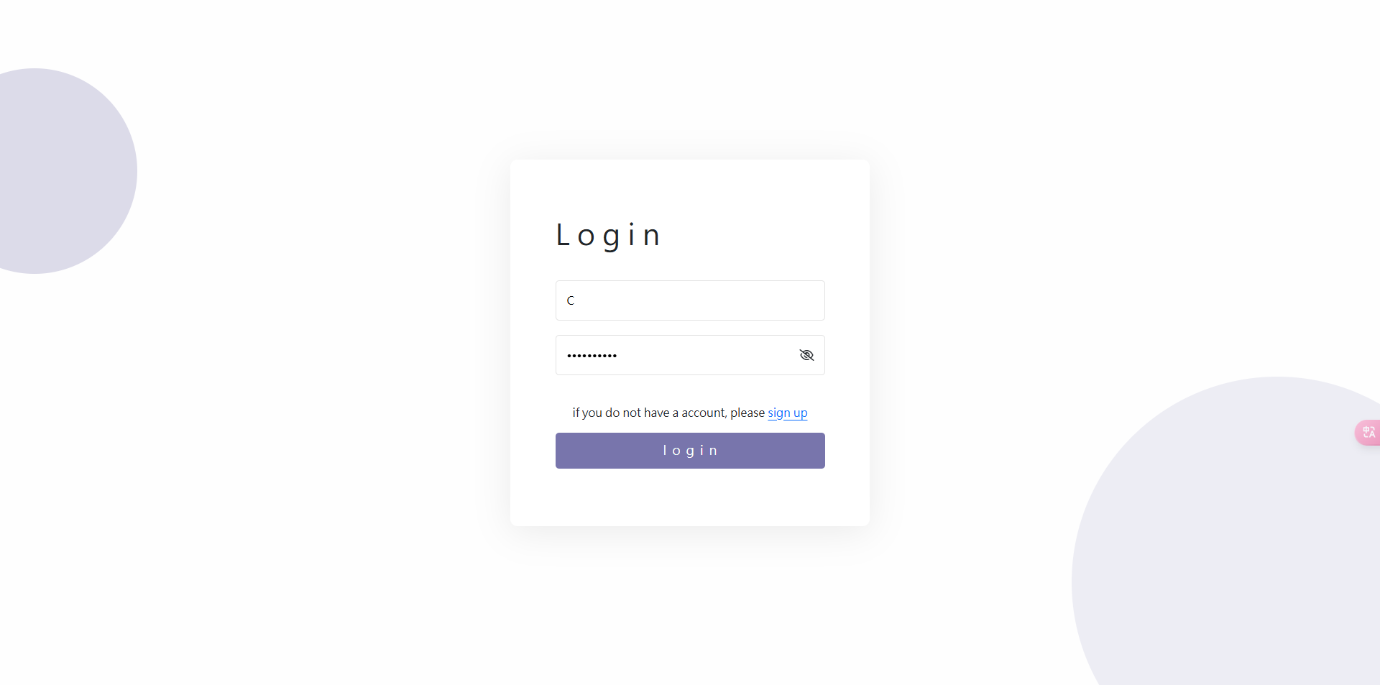

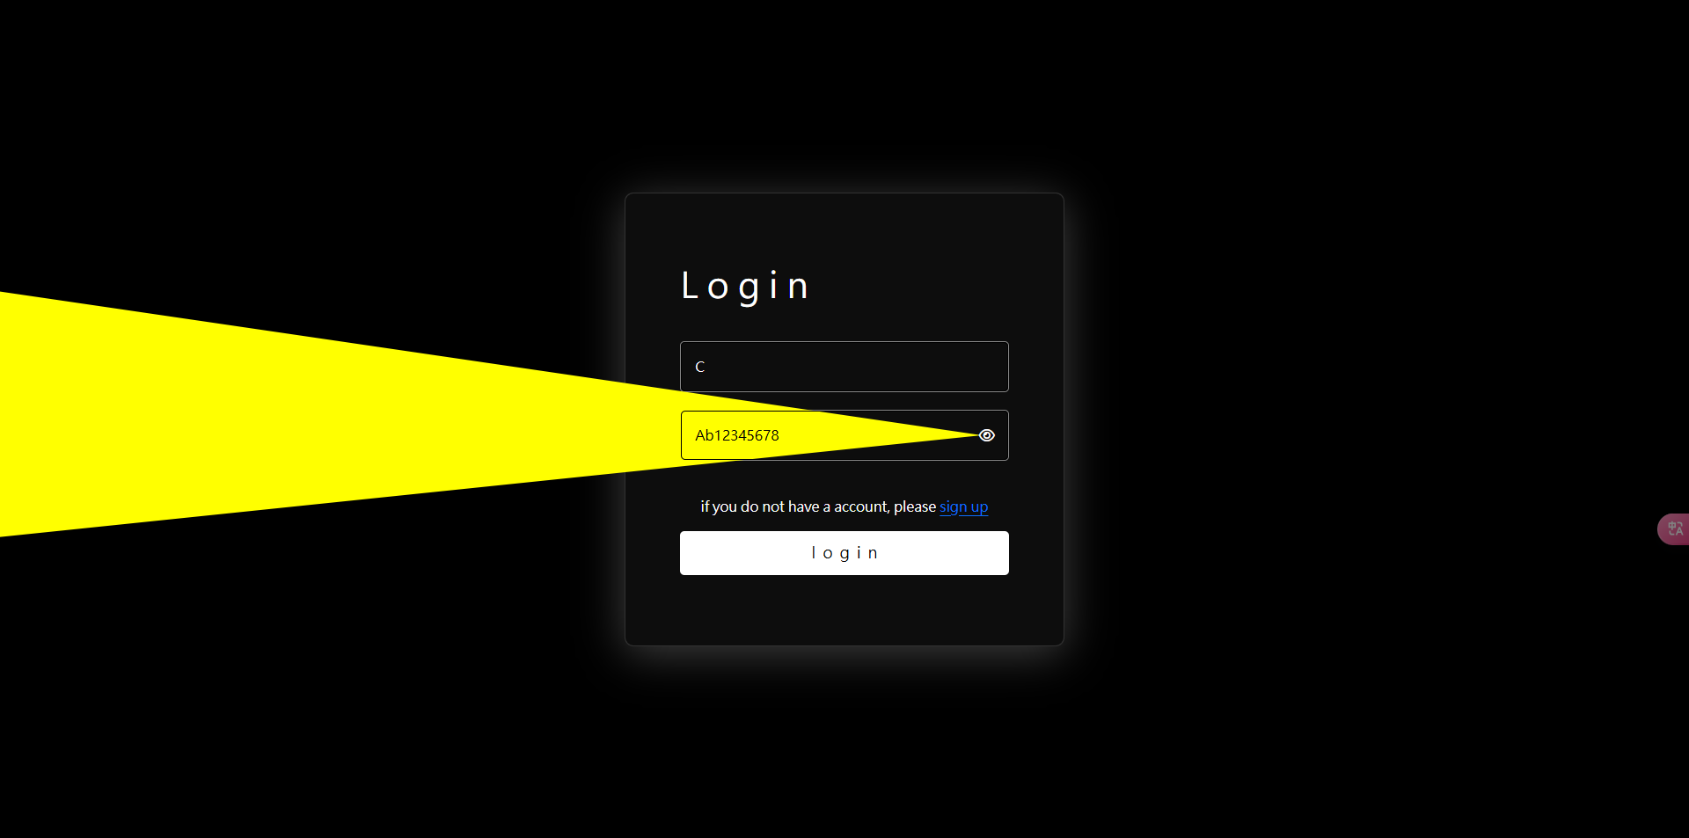

* Overall Layout: The page utilizes a clean and organized layout, with a central card container that draws attention to the login form. This design helps to minimize distractions, allowing users to focus on the task at hand, which is to log in.
* Background and Visual Elements: The background features soft, rounded shapes created using pseudo-elements (::before and ::after), which add a subtle depth and visual interest without overwhelming the user. The use of light colors (like soft grays) for the background helps to create a calm environment, while the card itself is white, providing a sharp contrast that makes the form stand out.
* Input Fields: The input fields are designed to be user-friendly and accessible. They have adequate padding and are sized appropriately to accommodate user input. The design employs clear borders and background colors, ensuring that users can easily identify the fields where they need to enter their information. Additionally, icons (like the eye icon for password visibility) are included to enhance usability.
* Button Design: The login and next buttons are prominently displayed with a bold color that stands out against the background. They are sized adequately to make them easily clickable, and their design includes rounded corners, which aligns with modern UI trends. The button text is also styled to enhance readability, with appropriate spacing and size.
* Error Handling and Feedback: The design incorporates mechanisms for error handling, such as highlighting invalid fields and providing clear messages to guide users if they encounter issues during login. This approach helps users to recover from errors efficiently, improving overall satisfaction with the login process.

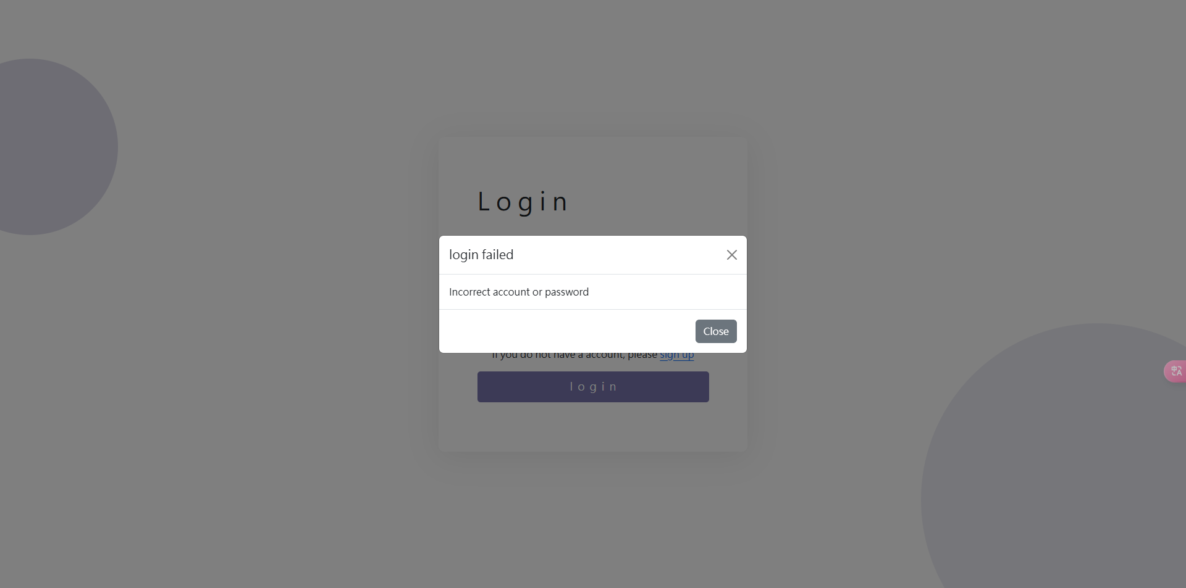

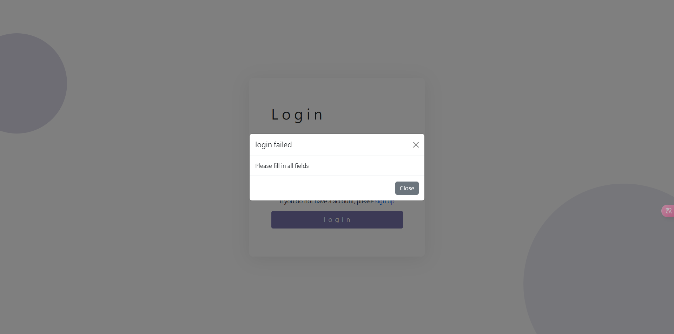

### Registrar

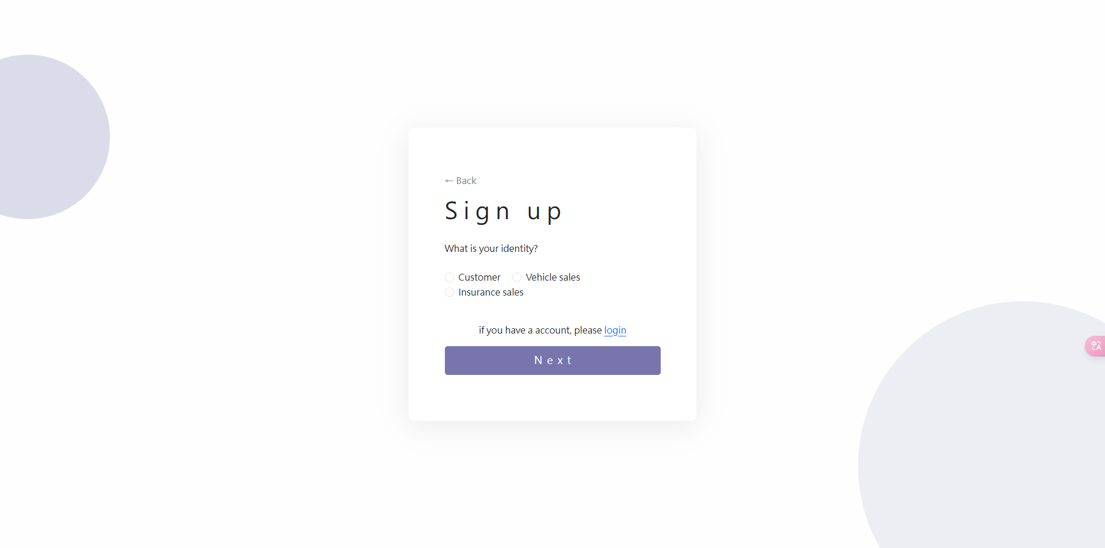

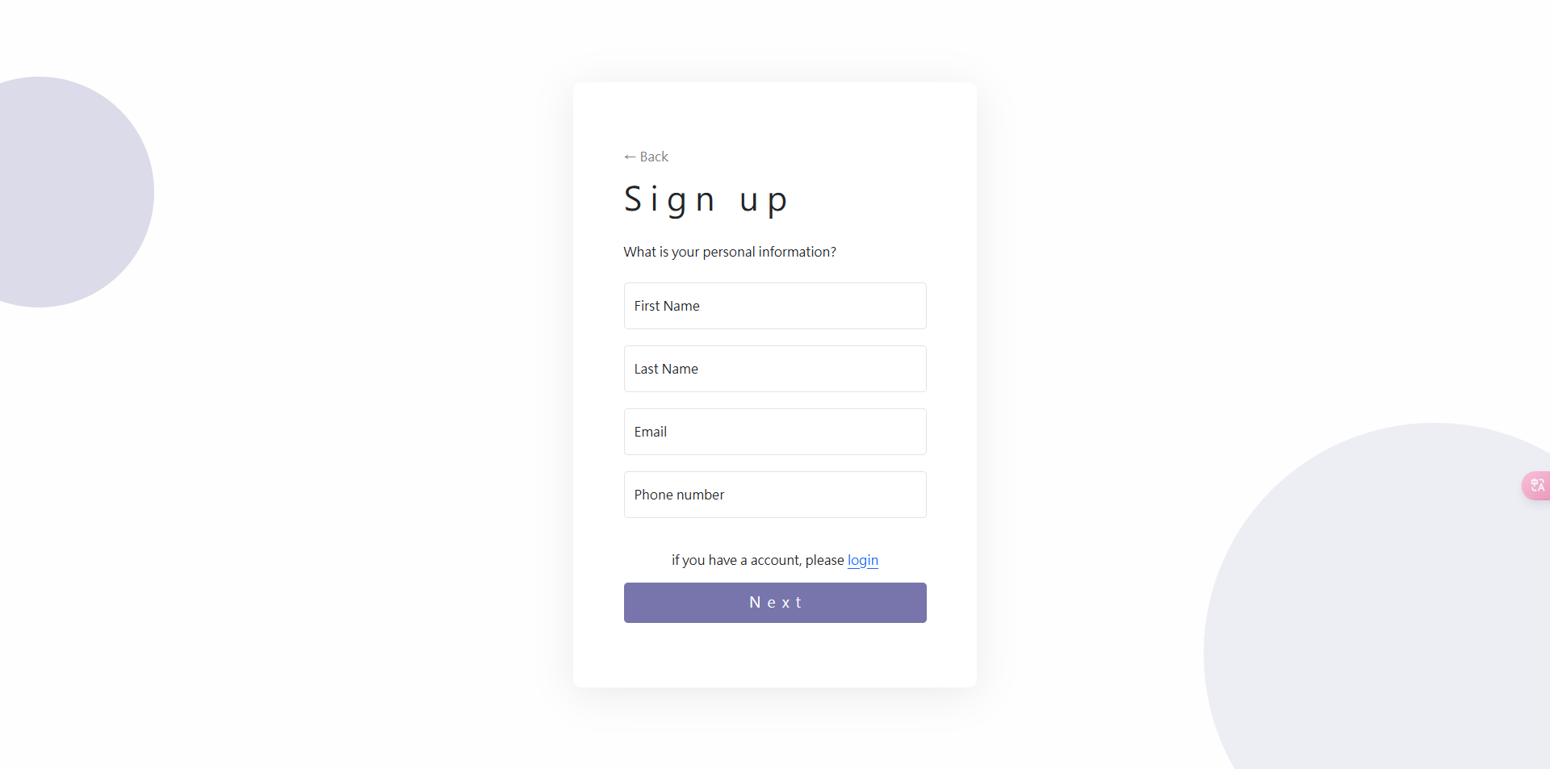

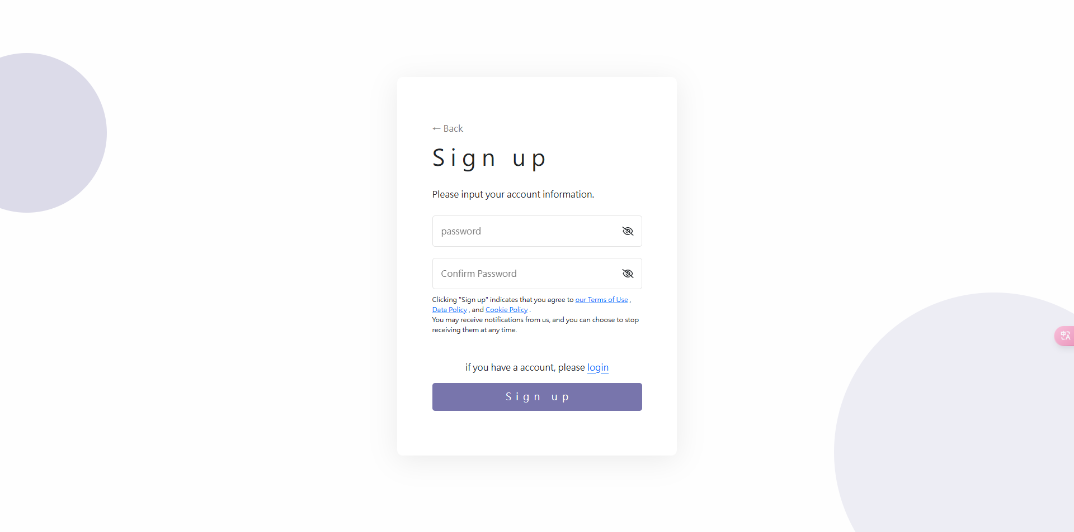

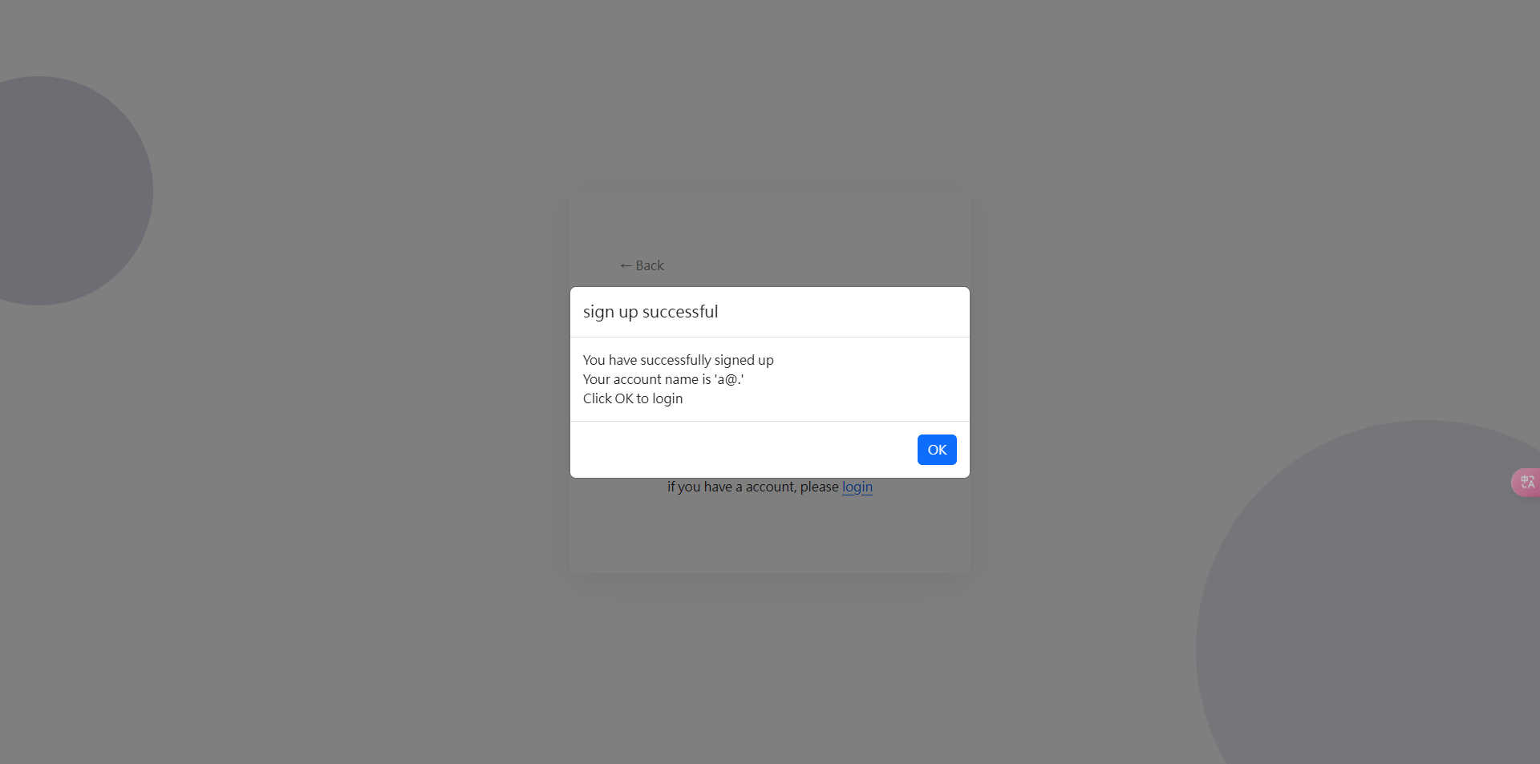

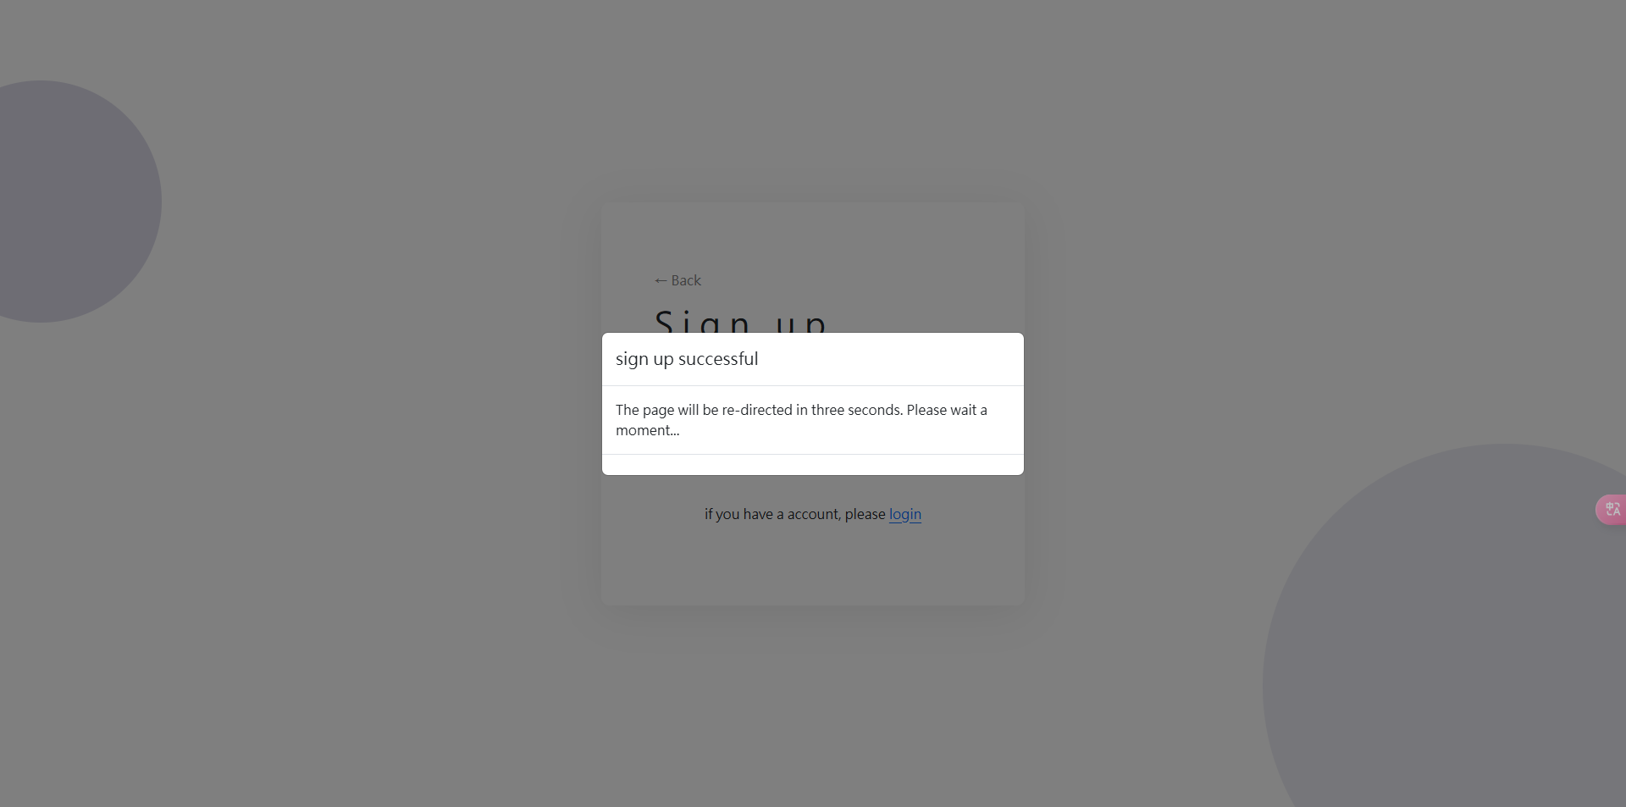

* Layout and Structure: The sign-up form is organized in a clear and logical manner, with input fields arranged vertically. This allows users to easily follow the flow of the registration process. The layout is designed to be intuitive, minimizing confusion as users fill out their details.
* Input Fields: Each input field is appropriately sized for the expected data, ensuring users can comfortably enter their information. Required fields are clearly indicated, often with asterisks (*) which guides users on what information is necessary to complete the registration. This approach helps prevent incomplete submissions.
* Error Handling: The design incorporates effective error handling mechanisms. If users fail to fill in required fields or enter incorrect information, the system provides clear feedback. For example, invalid fields can be highlighted with a distinct color, and messages are displayed, explicitly stating what the problem is. This minimizes user frustration and helps them correct mistakes easily.

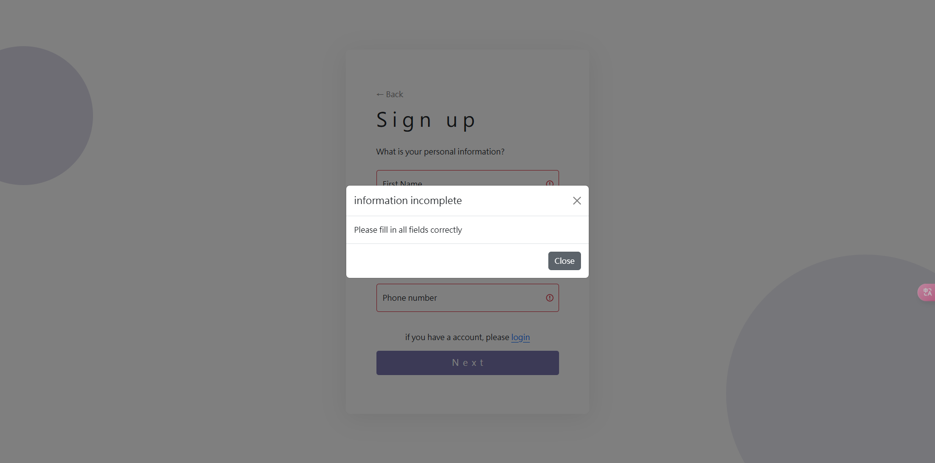

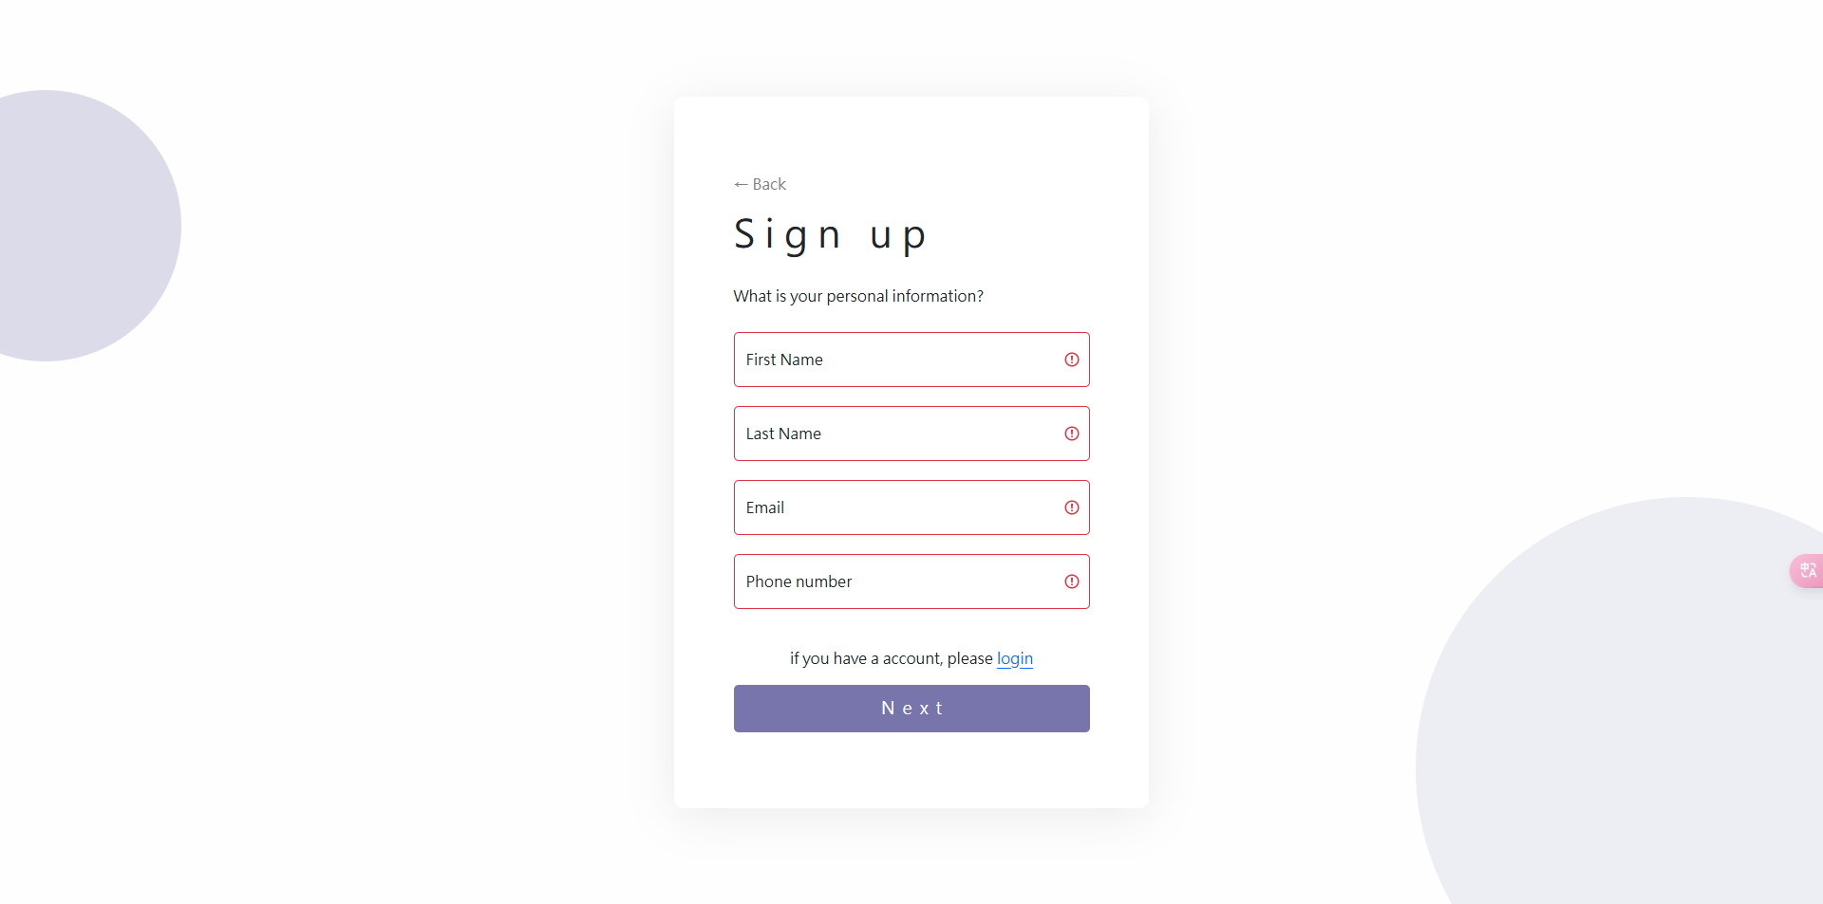

* Button Design and Placement: Consistency in button placement is maintained throughout the form. Action buttons, such as "Sign Up" and "Next," are placed after their associated input fields, making it clear what actions users should take after completing each section. The buttons are styled to be prominent and inviting, using colors that contrast well with the background.
* Visual Aesthetics: The overall visual design is clean and modern, using a color palette that is easy on the eyes. The card-style container for the sign-up form stands out against the background, drawing users' attention. The use of rounded corners and subtle shadows adds a sense of depth, making the interface feel more approachable.

### Payment

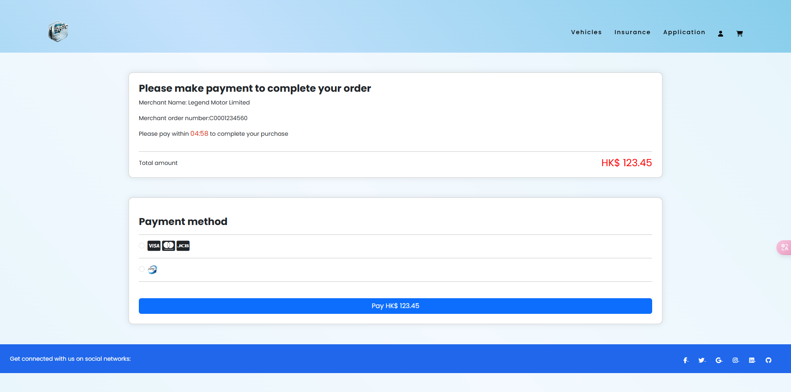

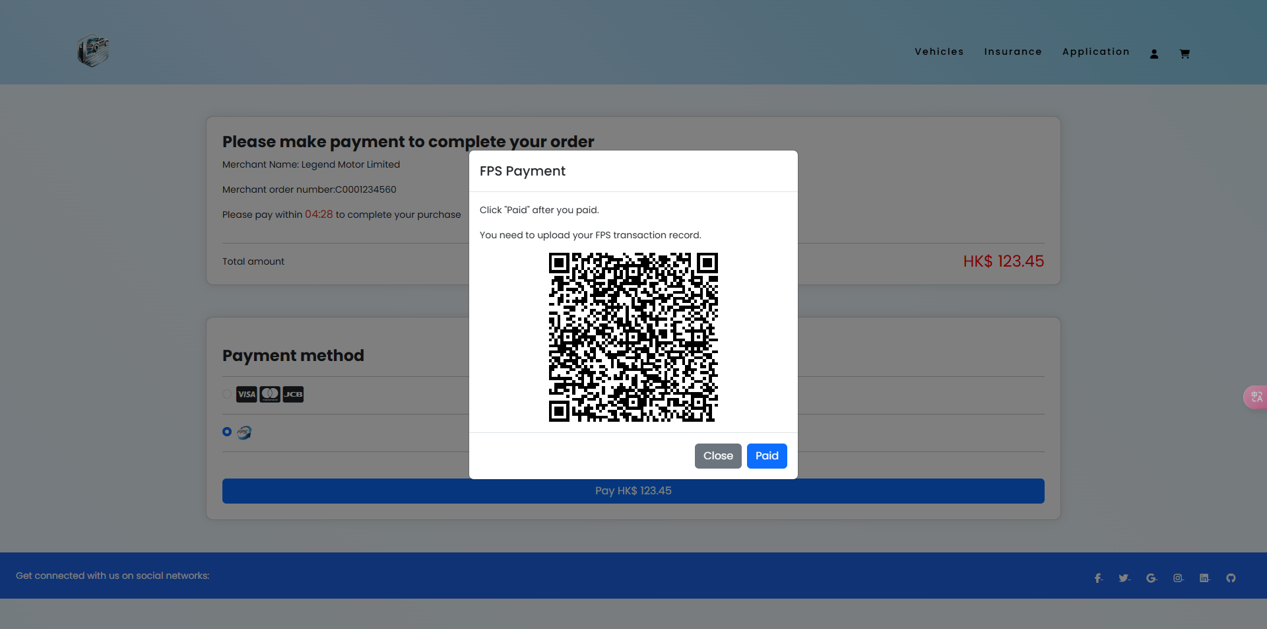

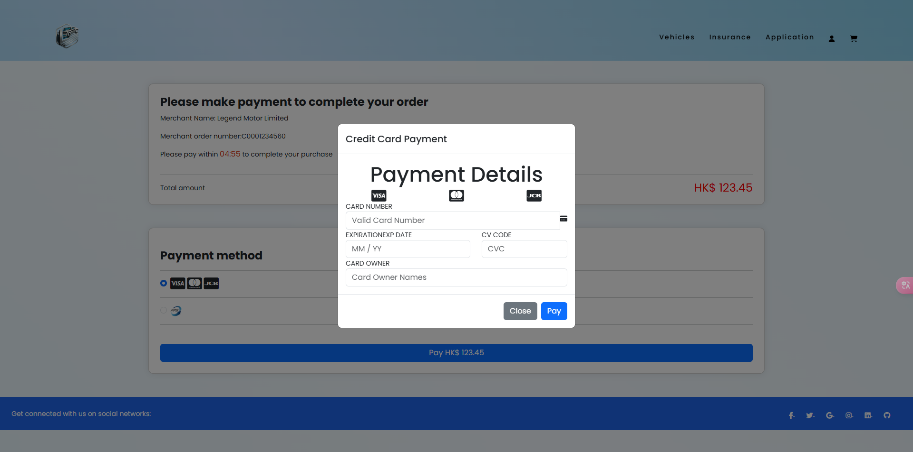

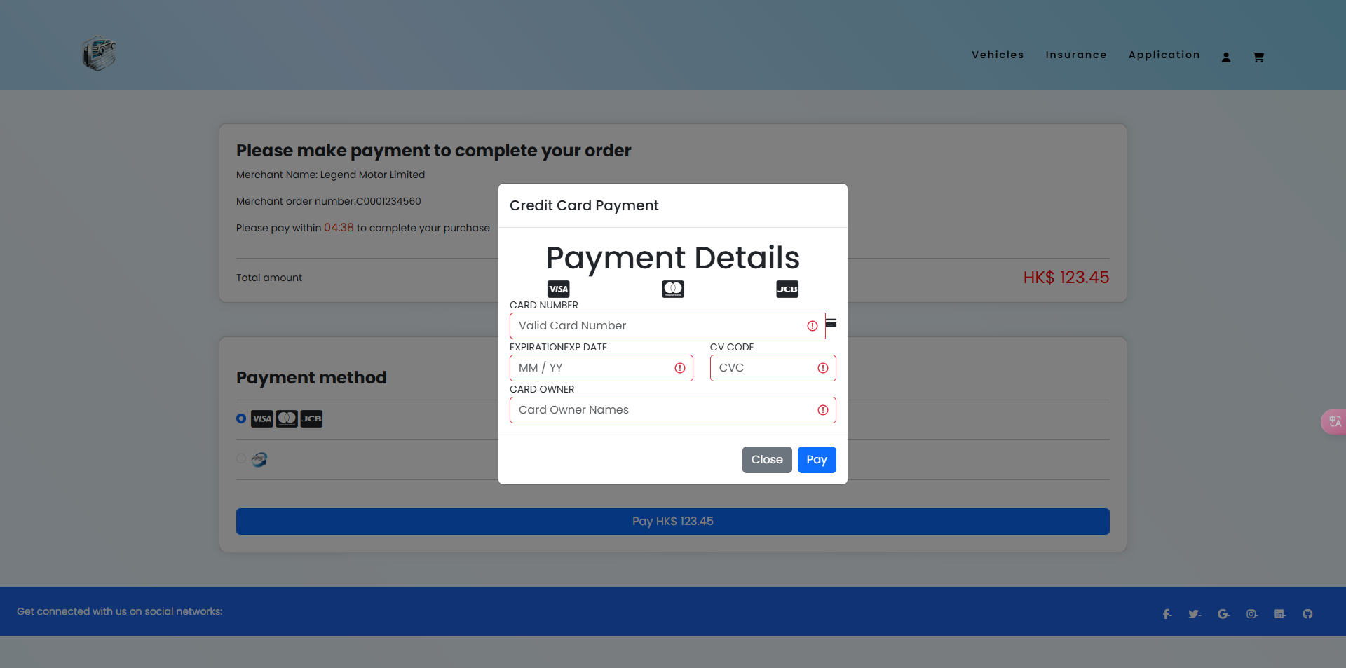

* User-Centered Design: The payment interface prioritizes the needs of the user by providing a clear and structured layout that allows users to easily navigate through the payment process. Each section is logically organized, with fields for the card number, expiration date, CV code, and card owner clearly labeled. This aligns with HCI principles that emphasize the importance of understanding user tasks and structuring information in a way that makes sense to users.
* Feedback Mechanisms: Effective feedback is crucial in HCI, and the payment process design includes mechanisms to inform users about their actions and any errors. For instance, if a user enters an invalid card number or an incorrect expiration date, the system can provide immediate visual feedback (such as highlighting the field in red) to prompt correction. This helps users feel more in control and reduces frustration, as they receive guidance on what needs to be fixed.
* Affordances and Signifiers: The design employs clear affordances and signifiers that indicate how users should interact with the payment fields. For example, the input fields are visually distinct and have placeholder text that helps users understand what information is required. This clarity is essential for reducing cognitive load, allowing users to focus on completing their payment without unnecessary distractions.
* Error Prevention and Recovery: HCI principles advocate for designing systems that help prevent errors and facilitate recovery when they do occur. The payment process likely includes input validation to ensure that users enter correct information before they can proceed. Additionally, clear prompts and instructions guide users through the process, which can help prevent errors and reduce anxiety.
* Visual Hierarchy: The payment page utilizes visual hierarchy to guide users' attention to the most critical elements of the interface, such as the total amount due and the payment method. By using font size, color, and spacing effectively, the design ensures that users can quickly identify and focus on the key components of the payment process, enhancing usability and efficiency.

### Nav Bar



Navigation bar uses a color contrast mechanism to enhance visibility and user experience. Initially, the navigation bar features a white background with black text. As the user scrolls, the design dynamically switches to a black background with white text. This transition supports visual contrast for improved readability under changing contexts.

The navigation bar is center-aligned, which aligns with the visual organization principle of alignment, creating a clean and symmetrical appearance.

* Consistency

The same font style and size are used throughout the navigation bar, adhering to design uniformity .

* Feedback and Affordance

The dynamic change in colors provides feedback to the user, indicating they’ve scrolled.

This visual cue reassures users that the navbar remains functional and

* Proximity

Related navigation elements are grouped logically, reducing cognitive load for users trying to locate a feature.

* Recognition Over Recall

The use of recognizable menu items and icons (user and cart) reduces memory burden, allowing users to quickly locate familiar functions without relying on recall.

### Footer

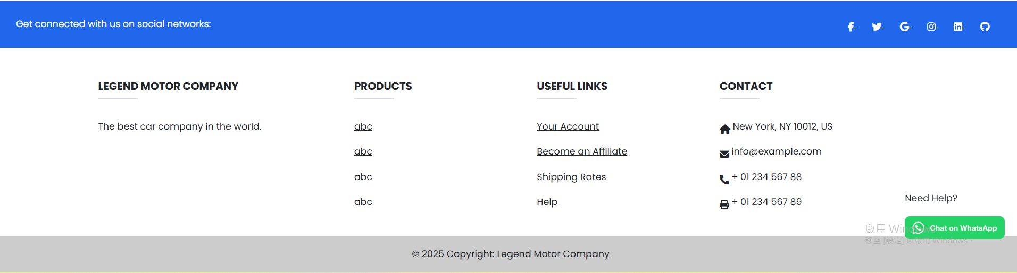

The blue header with social media icons at the top creates a visual hierarchy, drawing attention to connectivity and engagement.

The light gray bottom footer contrasts with the white content area, clearly separating sections while maintaining readability.

* Contrast

The blue and white colors enhance the readability of text and icons, following HCI guidelines for effective contrast.

* Consistency

The alignment of sections (Legend Motor Company, Products, Useful Links, and Contact) shows clear organization and uniformity.

* Recognition Over Recall

Familiar icons (e.g. Home, email) and labels make it easier for users to understand functionality at a glance.

#### Index Page

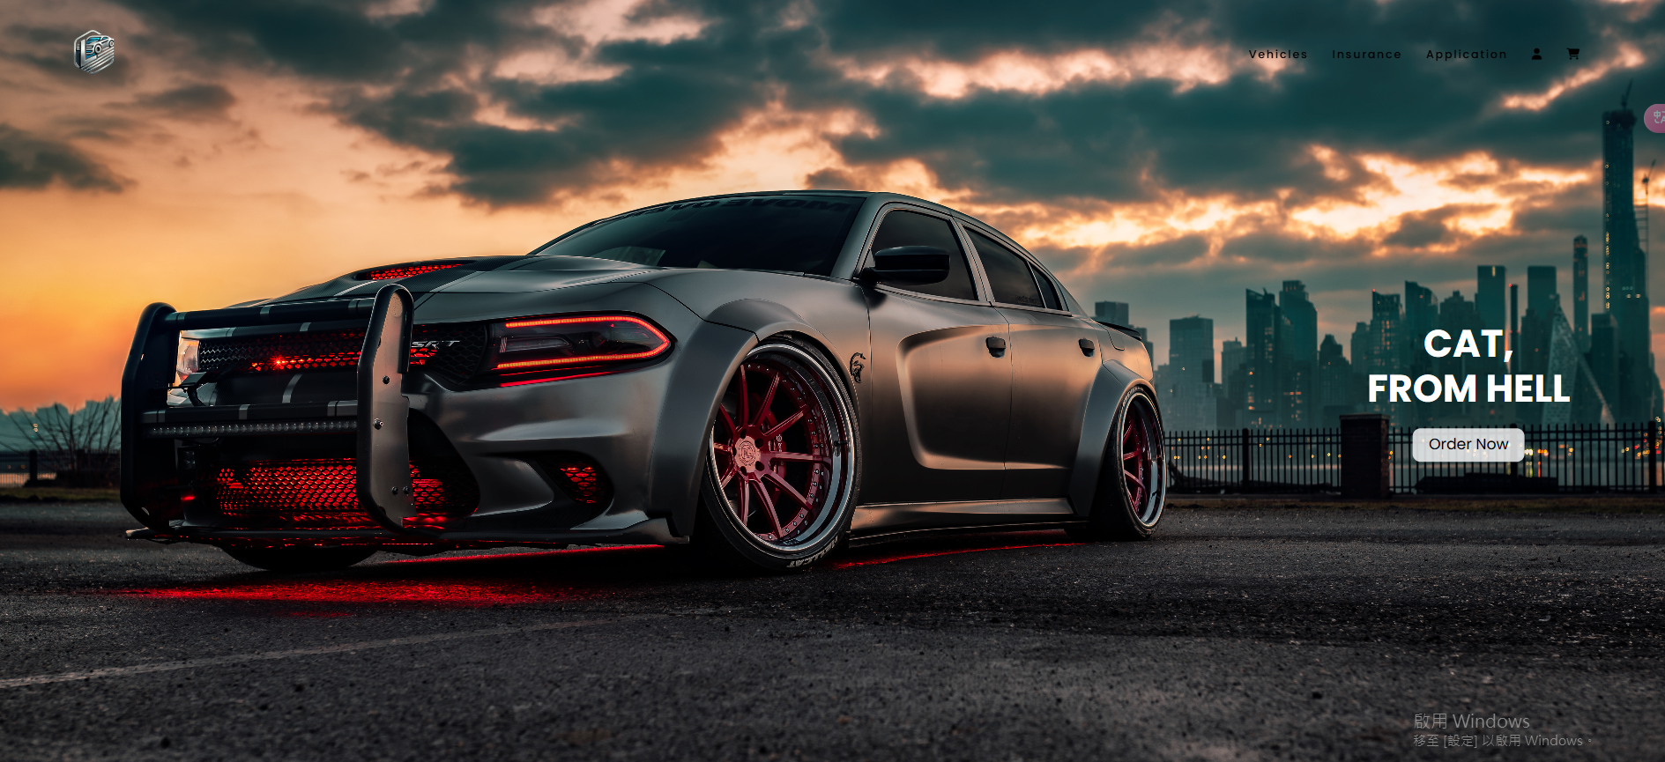

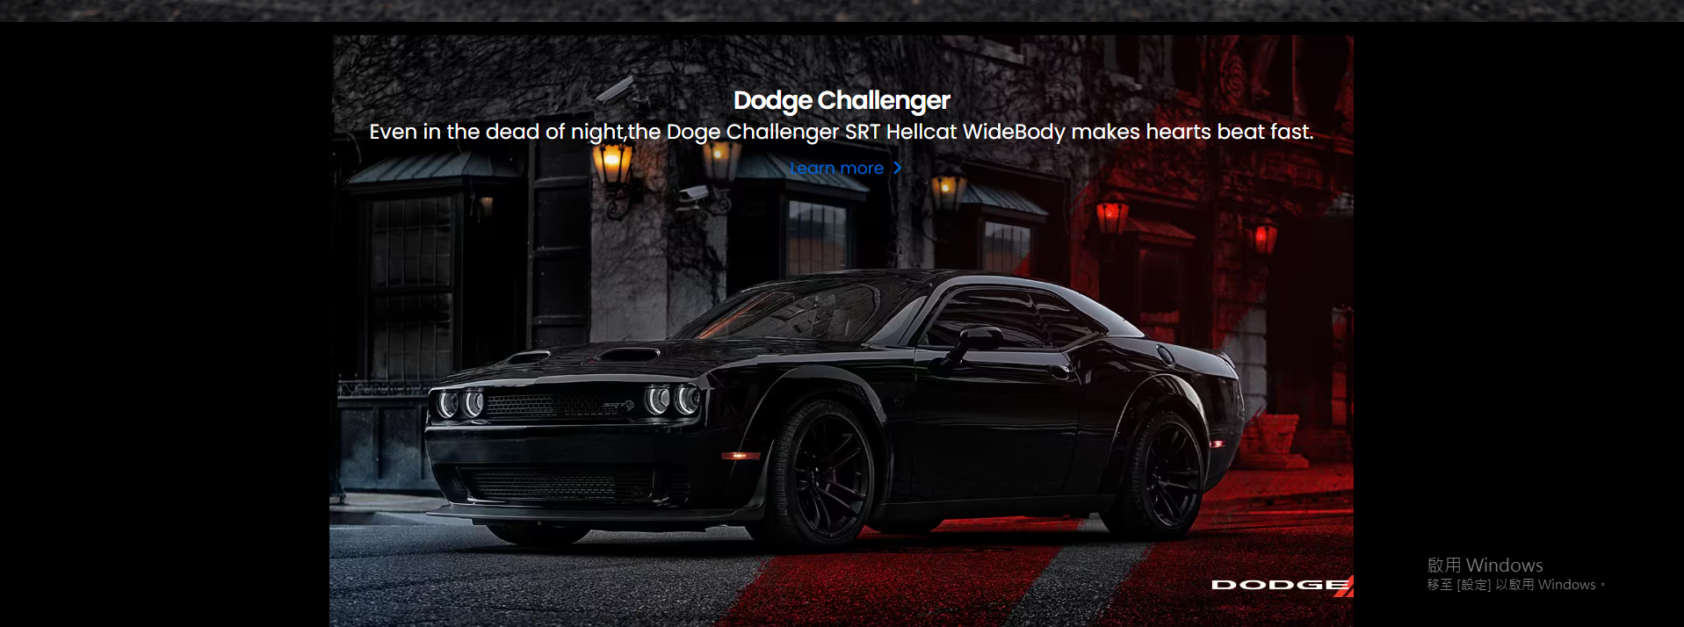

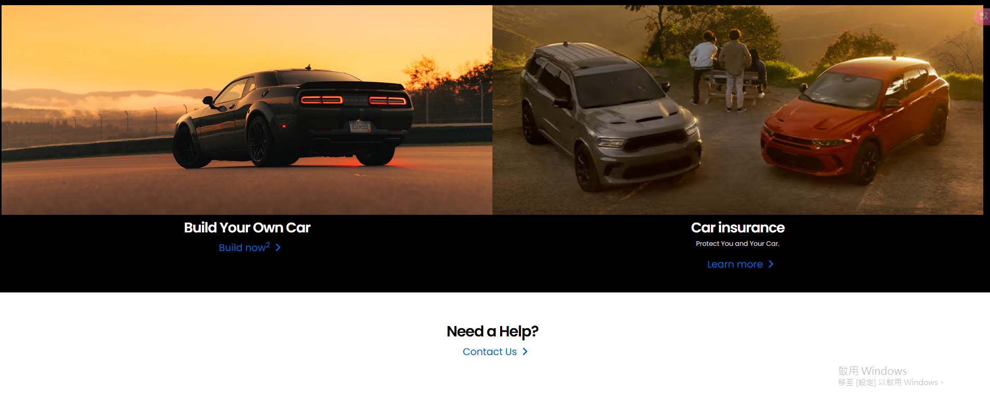The **hero section** contains a prominent call-to-action (CTA) button, which is clearly visible and leads the user to a key page (e.g., "Shop Now").

The **background image** and the text in this section are visually appealing and provide an engaging first impression.

## Vehicle Sales System

### Customer

#### Personal Information

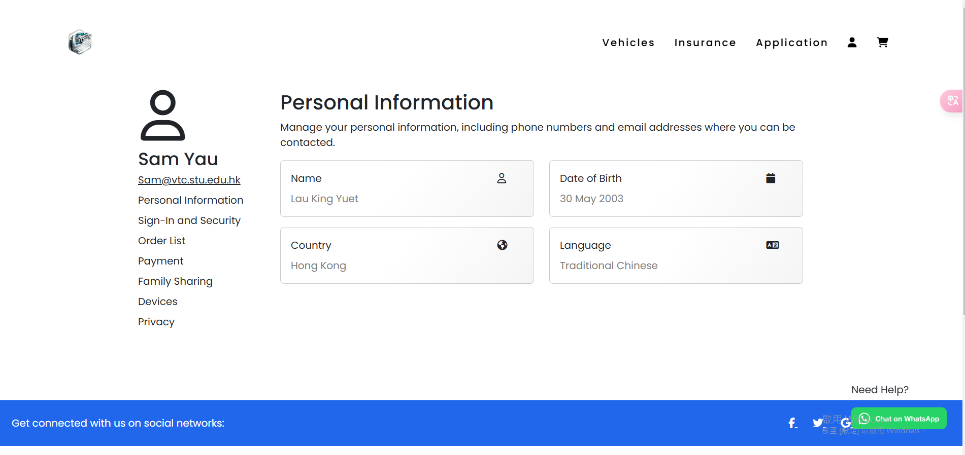

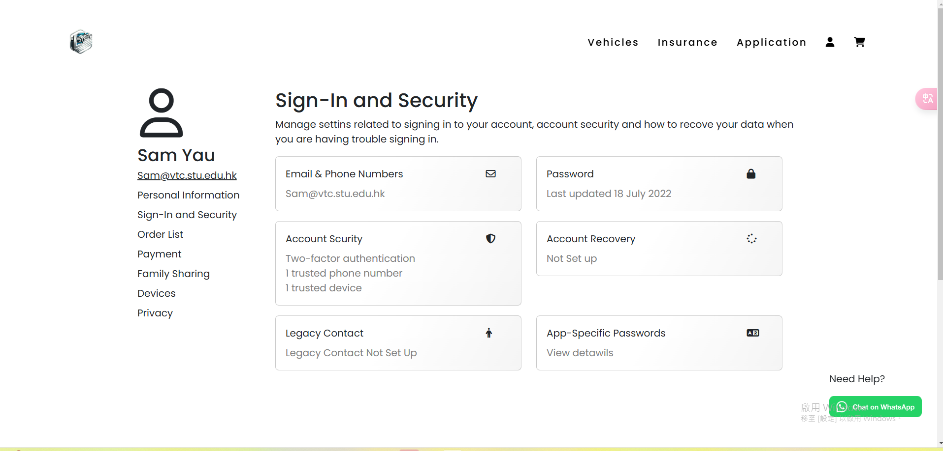

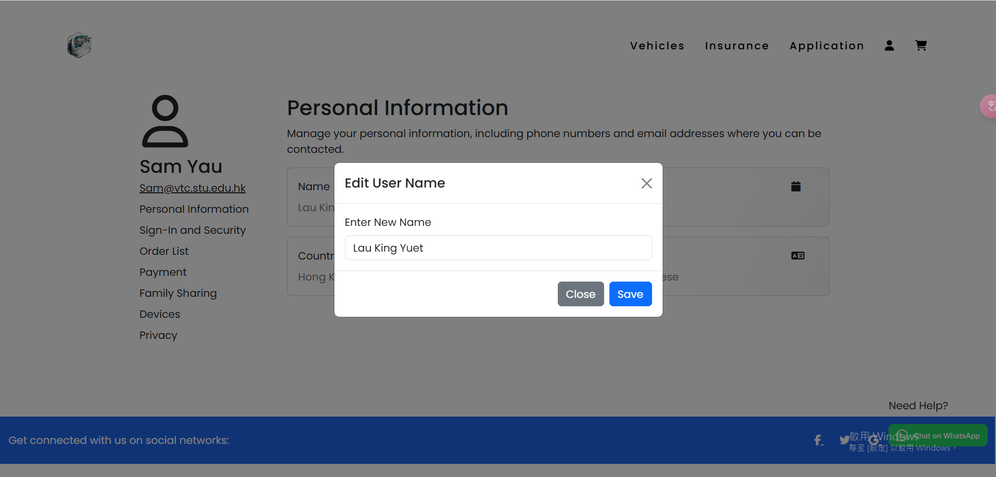

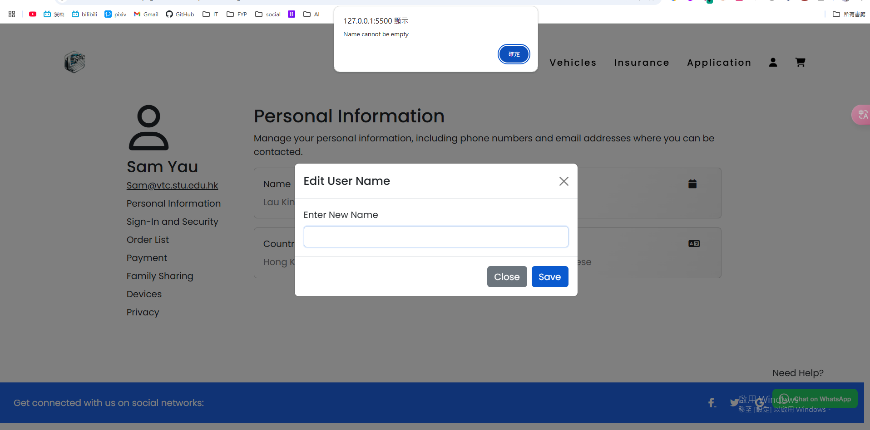  
**User Interface Components:**

**Input Fields**: The page contains various fields where users can enter their personal information. Each field has a clear label (e.g., "Name", "Email", "Phone"), making it intuitive for users to know what information is required.

**Modals**: When a user interacts with the central card, a modal window appears. This modal is used for entering or editing information, ensuring users focus on one task at a time.

**Error Messages**: If a user tries to leave any field empty, a clear error message ("Cannot be empty") is displayed, ensuring that the user is aware of the issue before they can submit the form.

**Interaction Flow**:

1. Clicking on the **central card** opens the **modal**, where the user can input their details.
2. If any input field is left empty, an error message appears immediately to guide the user to fill in the required information.
3. The **modal** cannot be closed by clicking outside of it, ensuring users cannot dismiss it unintentionally. It can only be closed by clicking the **"Close"** button, giving users full control over the interaction.

**Design Principles**:

* + - **Consistency**

The layout is clean and consistent with clear labeling for each input field. The use of modals to display specific information is consistent across the page, making the interaction predictable.

* + - **Error Prevention**

The design prevents users from submitting empty fields by displaying an error message immediately when a field is left blank. This proactive error prevention minimizes user frustration.

* + - **User Control**

The modal itself is an indication of the system’s status, showing that users need to interact with it before proceeding.

* + - **Visibility of System Status**

The modal itself is an indication of the system’s status, showing that users need to interact with it before proceeding.

#### Order List

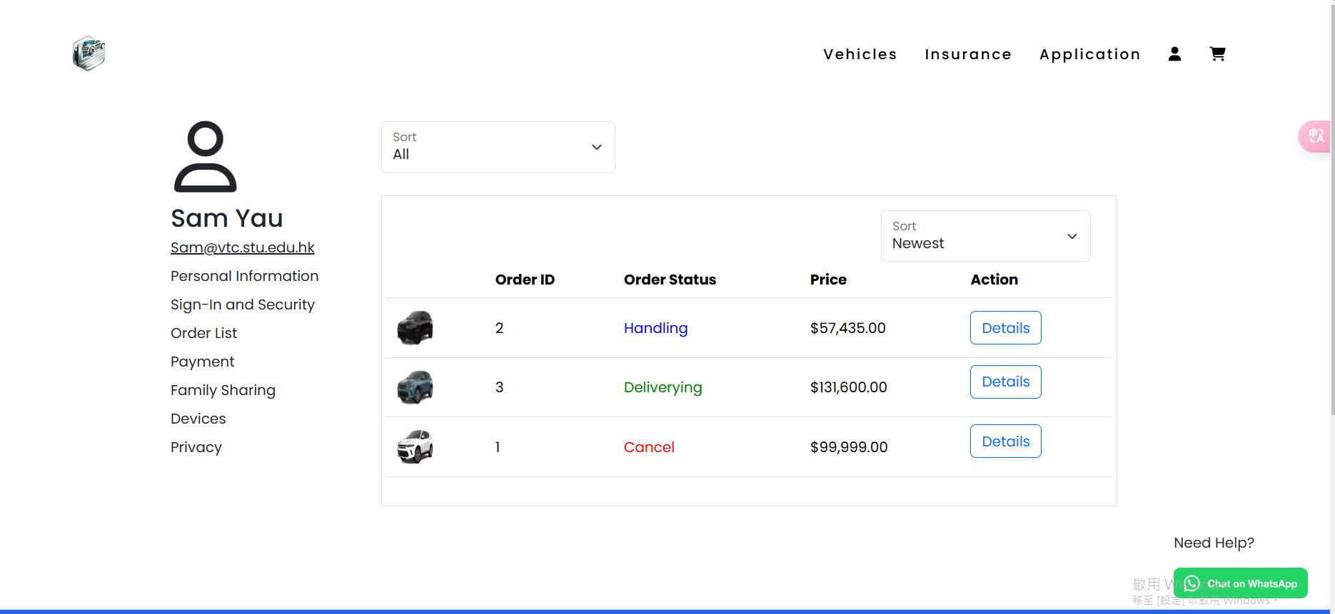

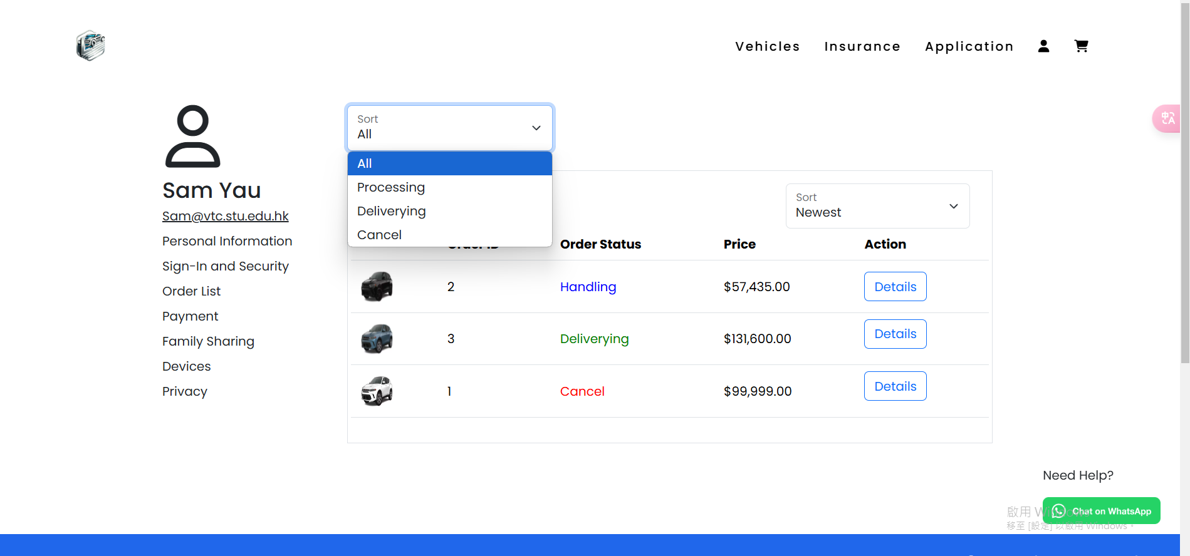 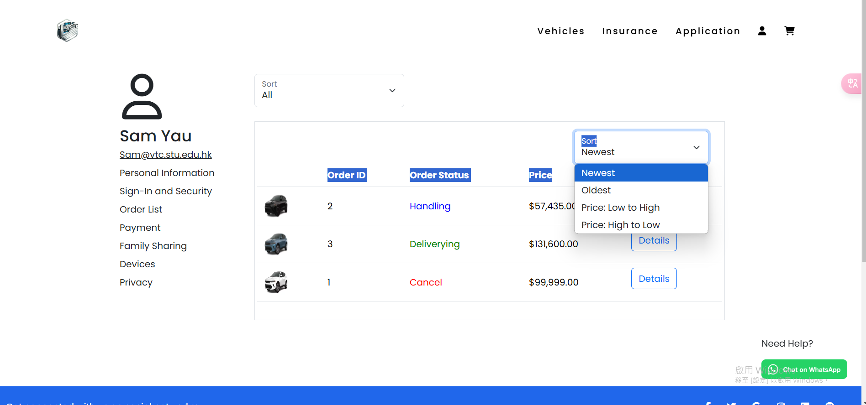

Two dropdown menus allow users to filter orders by status (e.g., "Processing", "Delivering", "Cancel") and sort them by criteria (e.g., "Newest", "Oldest", "Price: Low to High").

Each order row includes a **Details** button, which is consistently styled for quick access to detailed order information.

* **Consistency**

1. The design uses consistent styling for dropdowns, buttons, and the table structure, ensuring a predictable and intuitive user experience.
2. Labels and icons are uniformly styled to reinforce familiarity.

* **Feedback**

1. Dropdown interactions provide immediate feedback by displaying the selected filter or sorting option.
2. Color-coded statuses give instant visual feedback about the order's progress.

* **Recognition Over Recall**

1. Color-coding of statuses reduces the cognitive load, allowing users to quickly recognize the meaning of each status without needing to recall details.
2. Clear labels like "Details" help users immediately identify actionable elements.

* **Visibility of System Status**

Filters and sorting options dynamically update the displayed list, ensuring users are aware of the system's current state.

* **Flexibility and Efficiency of Use**

Dropdown menus for sorting and filtering accommodate both novice users (simple clicks) and advanced users (specific filters), making the interface versatile.

* **Error Prevention**

Dropdown menus limit options to valid statuses or sorting criteria, ensuring users can't select an invalid option.

### Vehicle Sale

#### Vehicles Shop

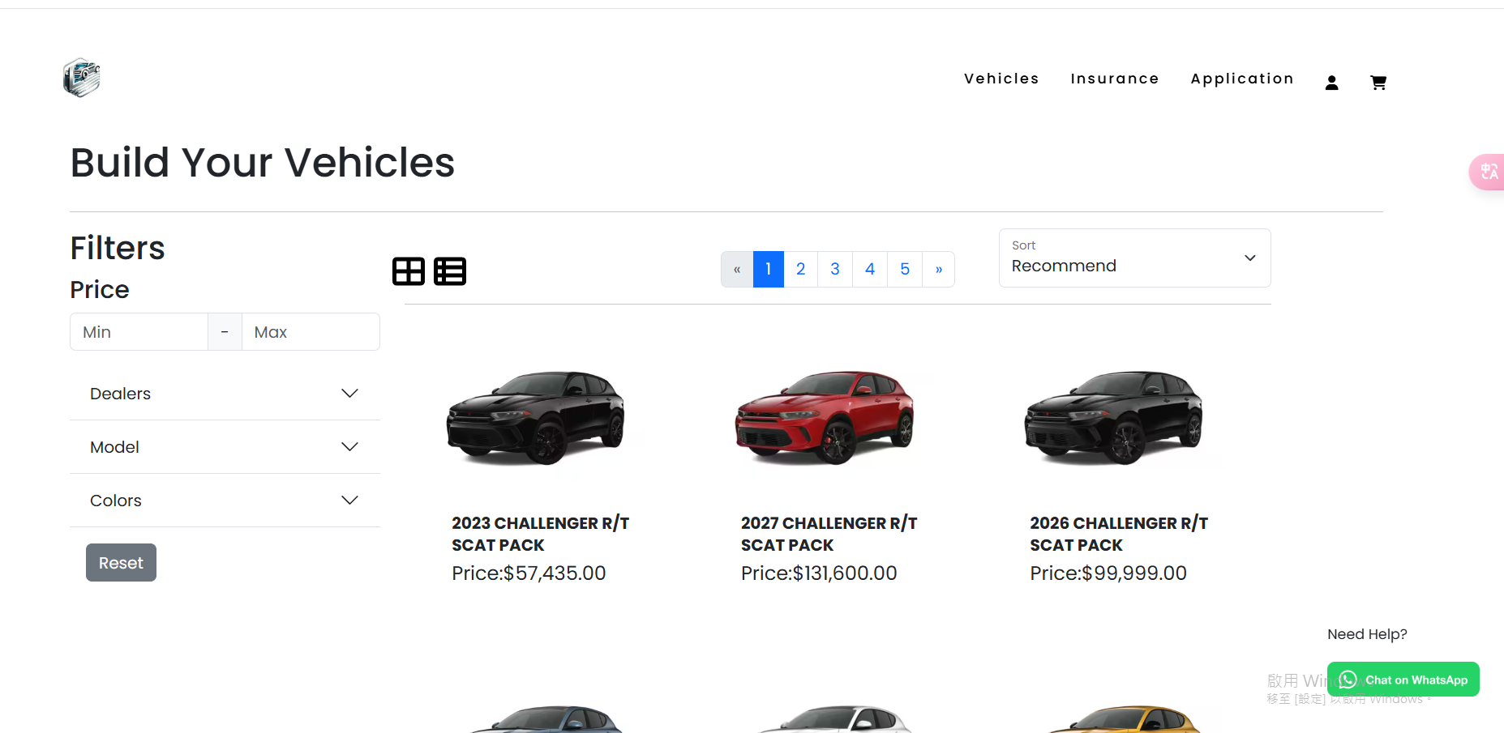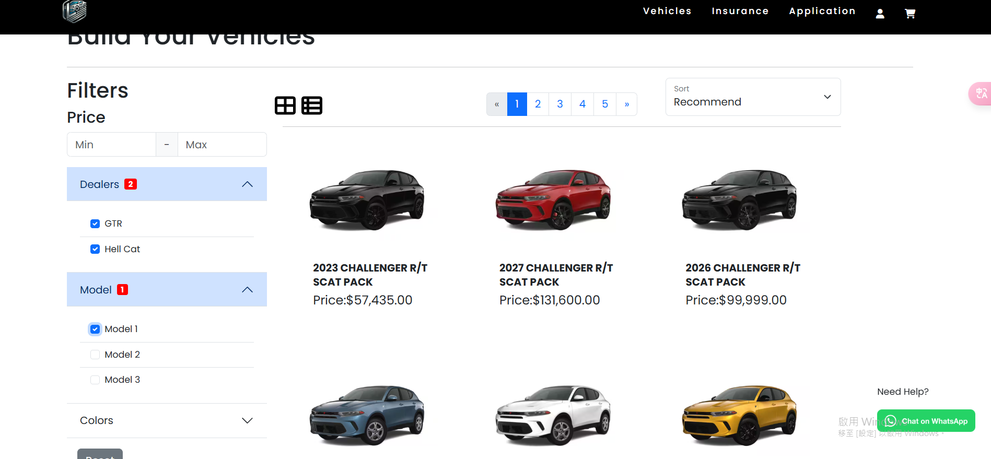

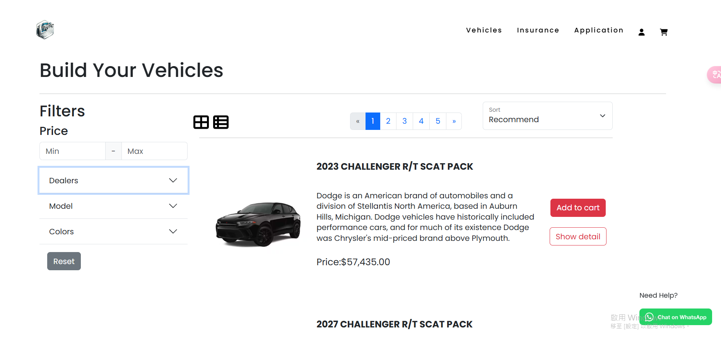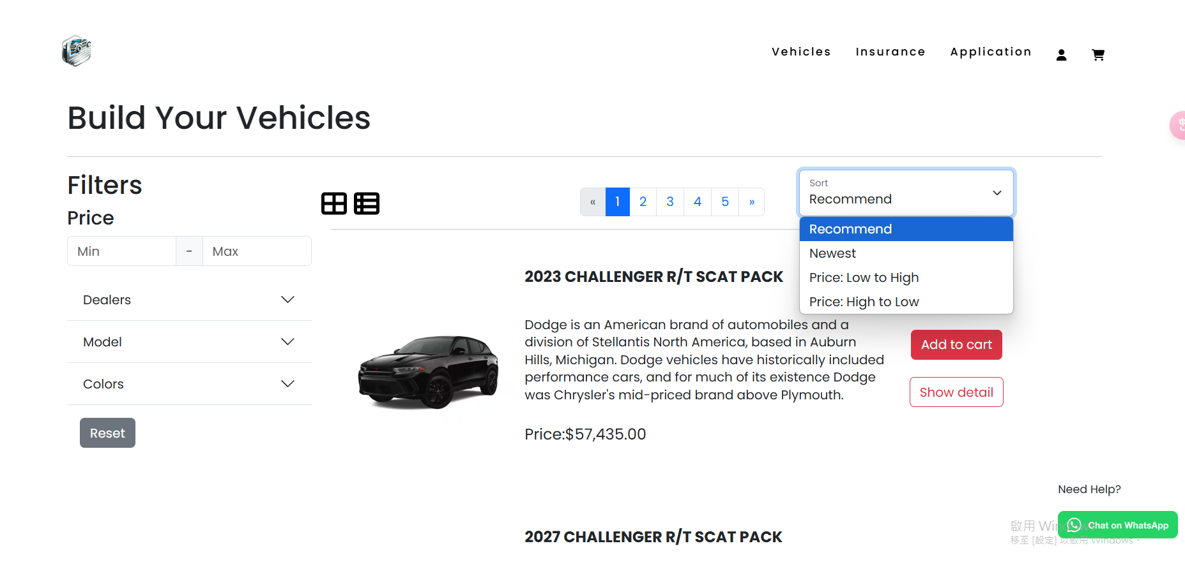

Users can toggle between the list and card views easily. The option to switch allows for **user flexibility**

The page displays the order details in a **table format**, which is structured with columns for order ID, status, price, and actions. This helps present information clearly and allows users to scan and compare orders easily.

There are dropdown menus for sorting and filtering orders based on their status (e.g., “Processing”, “Delivered”, “Canceled”) and sorting options (e.g., “Newest”, “Oldest”, “Price: Low to High”). This provides **flexibility** in how users view their data.

The table includes **action buttons** like "View Details" and "Cancel" for each order. These are clearly marked and are consistent across all orders.

* **Consistency**

The use of **uniform design elements**, such as consistent fonts, button styles, and dropdown menus, creates a predictable and easy-to-navigate interface

* **Visibility of System Status**

The table structure and color coding of statuses provide **immediate feedback** to users about their orders’ status. The search bar and pagination indicate the current state of the data being displayed, and the users can easily see how their actions (filtering, sorting, or searching) affect the data being presented

* **Recognition Over Recall**

The **color coding** of statuses and the use of **actionable buttons** like "View Details" and "Cancel" help users quickly recognize actions without needing to recall what each color or button does

When a user selects a filter or sorting option, the table updates dynamically, providing **visual feedback** that the system has responded to the user’s choice. This aligns with the principle that users should be informed about the results of their actions

* **Flexibility and Efficiency of Use**

The **filters** and **sorting options** give users the flexibility to view their orders in different ways based on their needs, whether they prefer to sort by price, newest, or status. Additionally, the search bar and pagination help improve the efficiency of accessing specific orders

* **Error Prevention**

The color coding and status labels help prevent mistakes, ensuring users can immediately identify if something is wrong with an order (e.g., canceled orders in red). This reduces the likelihood of users missing critical information

#### Check Out

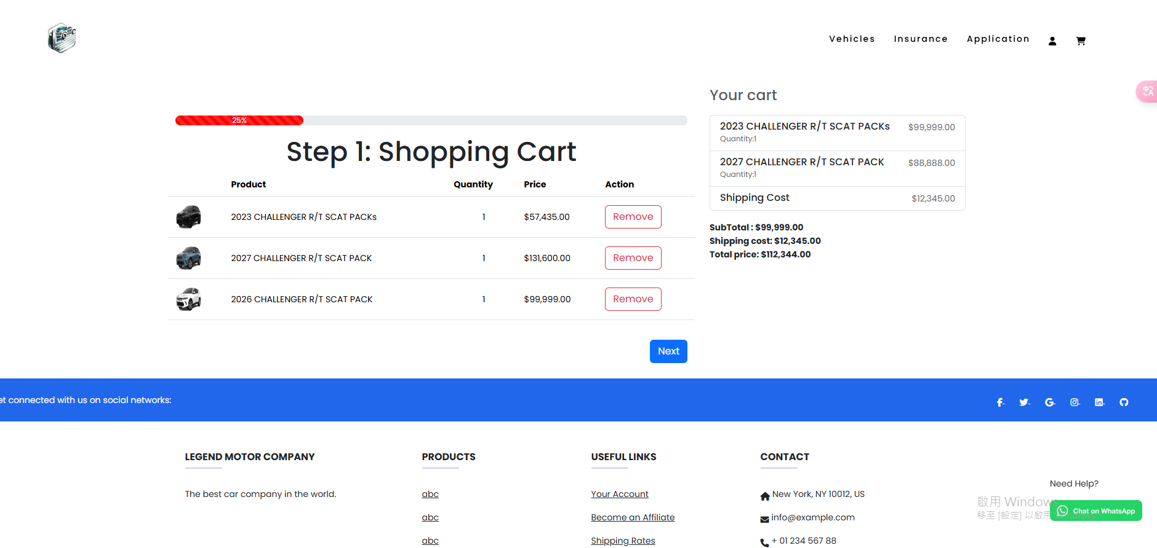 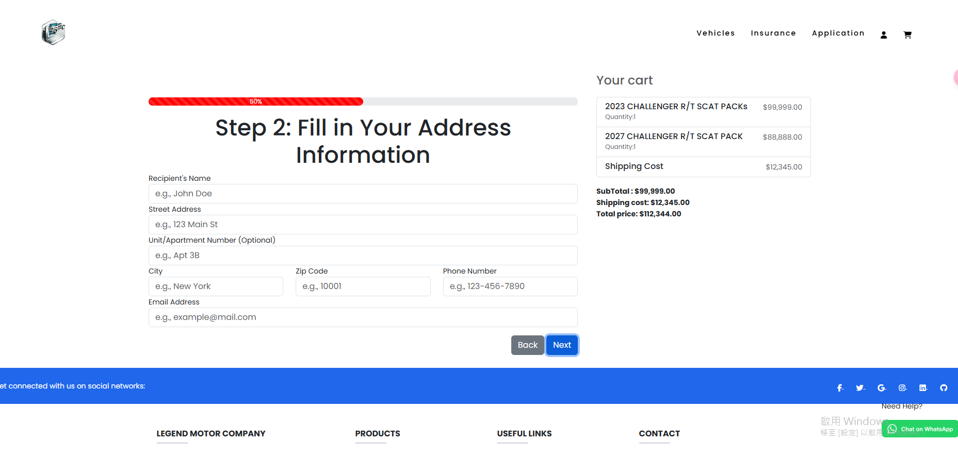 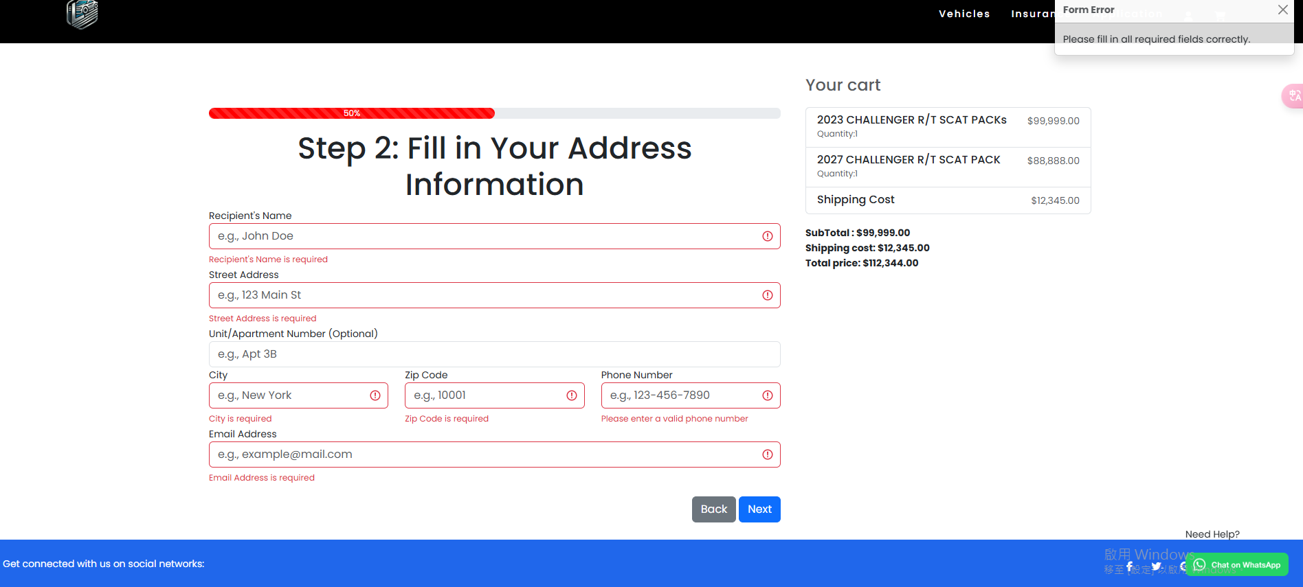 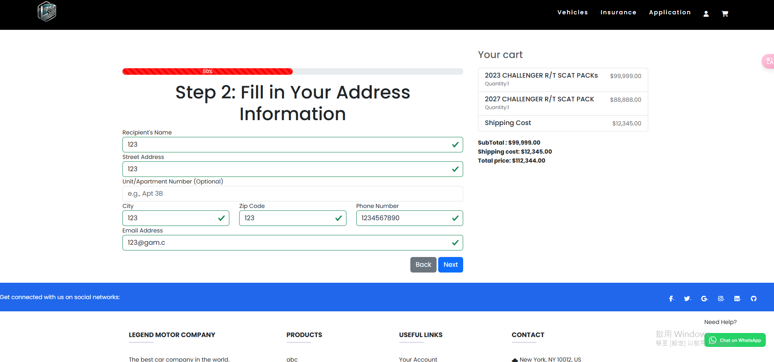 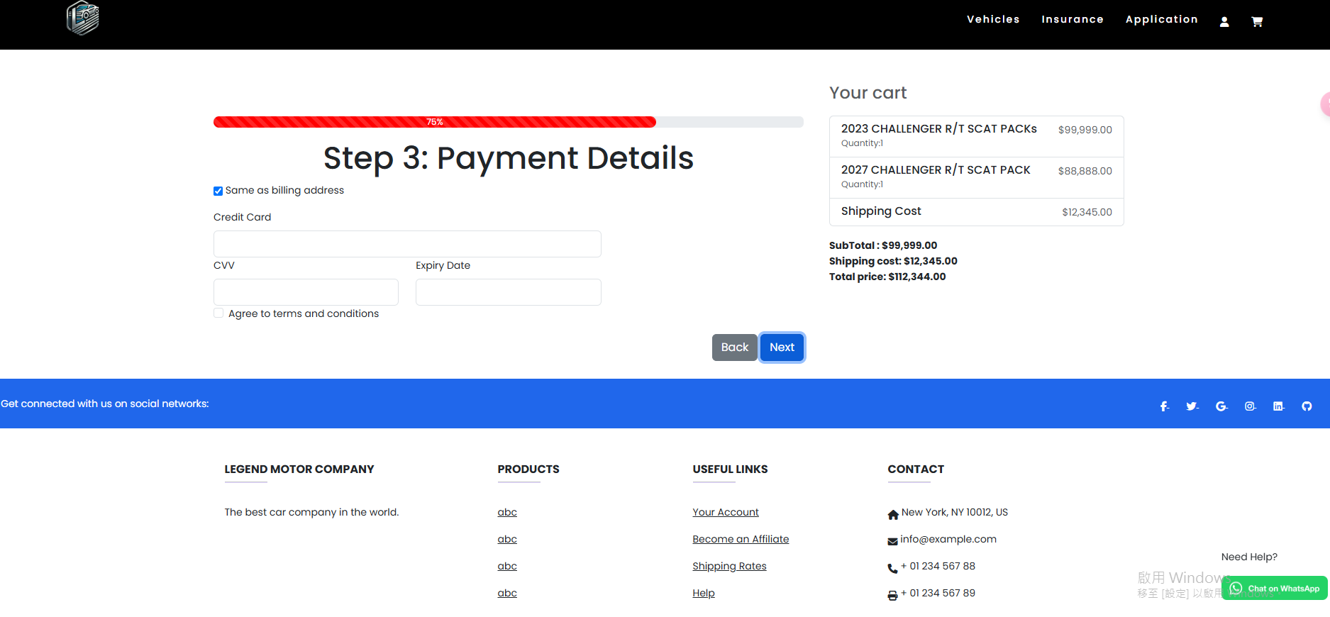 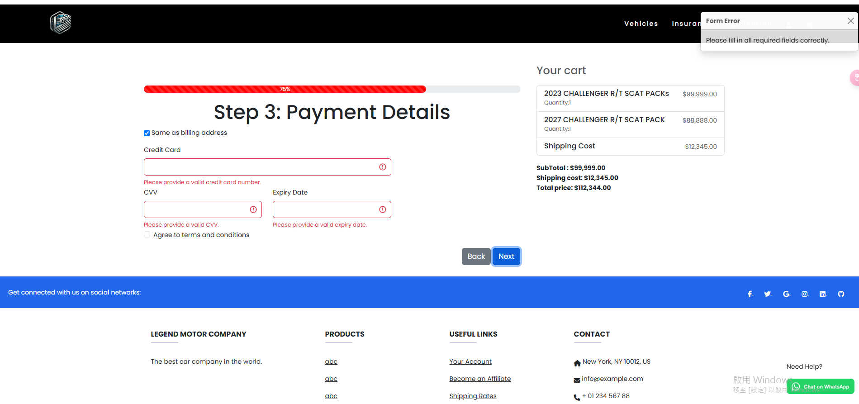 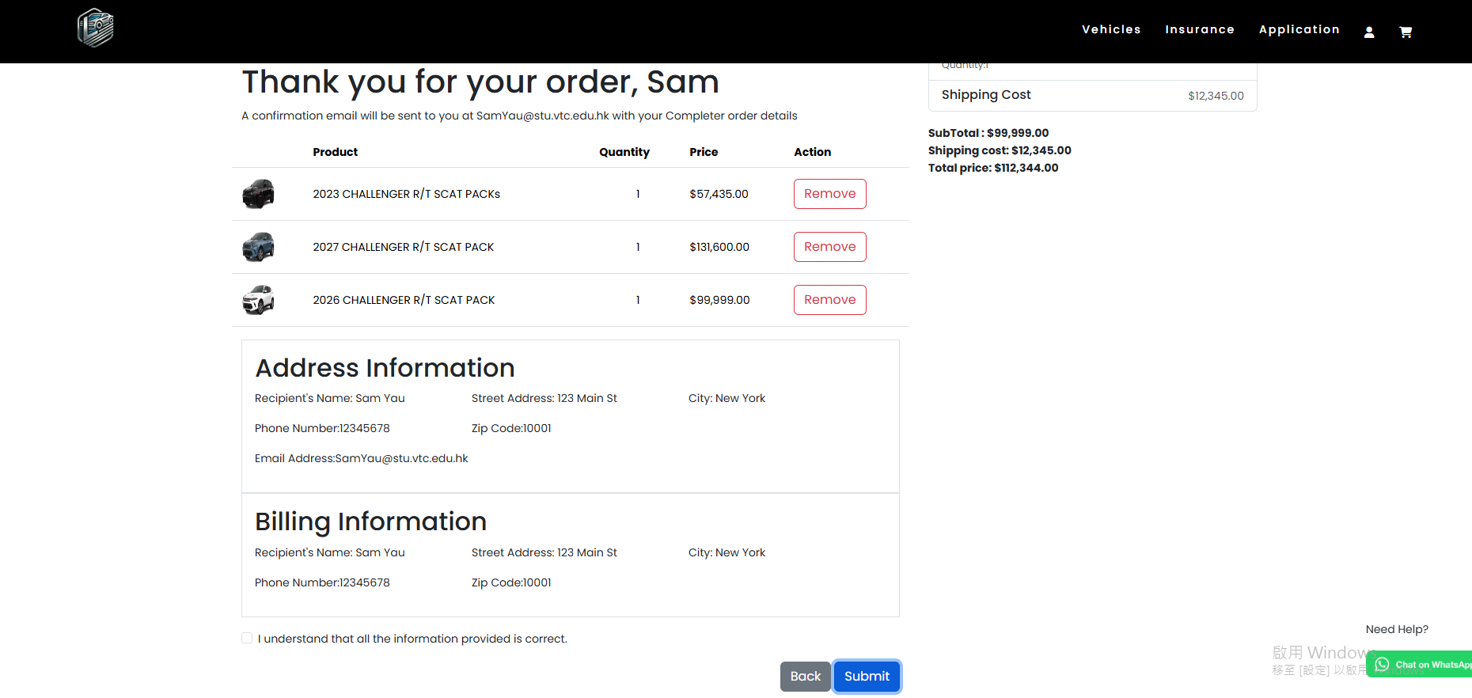 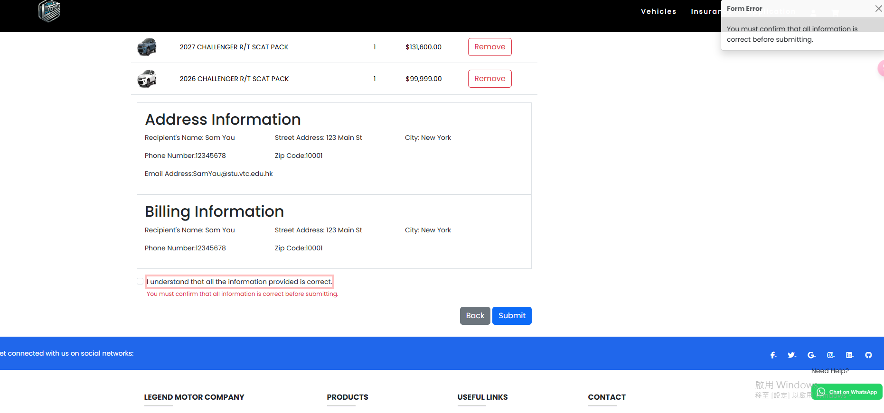

The checkout page contains multiple sections (e.g., Billing Information, Shipping Address, Payment Details) that are clearly separated into distinct fields.

Each field has a clear label, which guides users to fill in the required information, making the process easy to follow.

There is a checkbox asking users if their billing address is the same as the shipping address. If unchecked, users are prompted to fill in the billing address, reducing the cognitive load for users when the addresses are the same.

Button States:

The ‘Next’ button is only enabled once all required fields are filled. This prevents users from proceeding with incomplete information.

Error Prevention and Feedback:

The page uses real-time validation to ensure that all required fields are filled before proceeding. If a field is left empty, an error message is displayed, notifying the user of the issue.

Clear Visual Hierarchy:

The page uses a visual hierarchy with section headings (e.g., “Shipping Address”, “Payment Details”) in bold and larger fonts, making it easy for users to scan the page and find the information they need.

**Consistency**

* The page maintains consistent design elements, such as button styles, input field layouts, and fonts, providing a **predictable and familiar** experience for the user

**Error Prevention**

* The design ensures that users cannot proceed with **incomplete** information by disabling the **‘Next’ button** until all required fields are filled, preventing errors before they occur

**User Control and Freedom**

* The checkbox for the billing address allows users to make a simple choice, giving them **control** over their checkout process.

**Feedback**

* **Real-time feedback** is provided when a user leaves a required field empty. Error messages are displayed immediately, so users know exactly what needs to be corrected before they can proceed

**Visibility of System Status**

* The **‘Next’ button** clearly indicates whether the form is complete or incomplete, providing users with immediate visibility of the system’s status

**Recognition Over Recall**

* The use of **checkboxes** and **clear labels** reduces the cognitive load for users, allowing them to **recognize** required actions easily rather than needing to recall information

**Aesthetic and Minimalist Design**

* The page has a clean and organized layout, ensuring that only **necessary information** is displayed, which minimizes distractions and makes the process smoother for the user

#### Vehicles

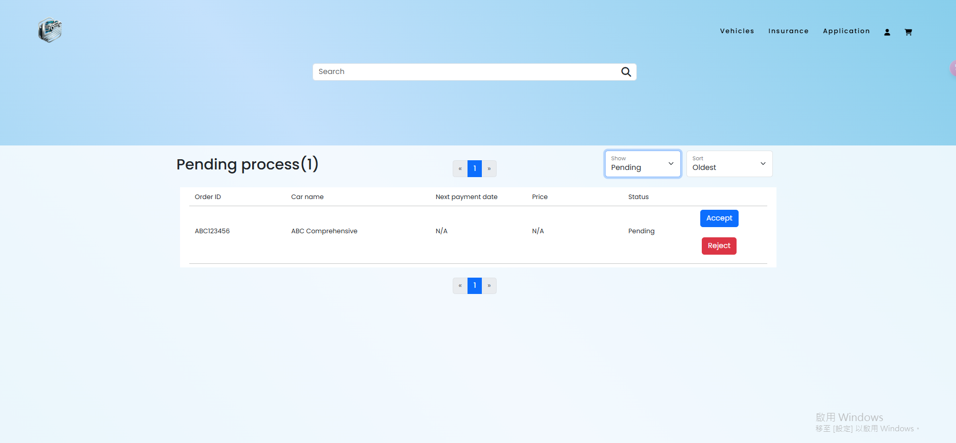

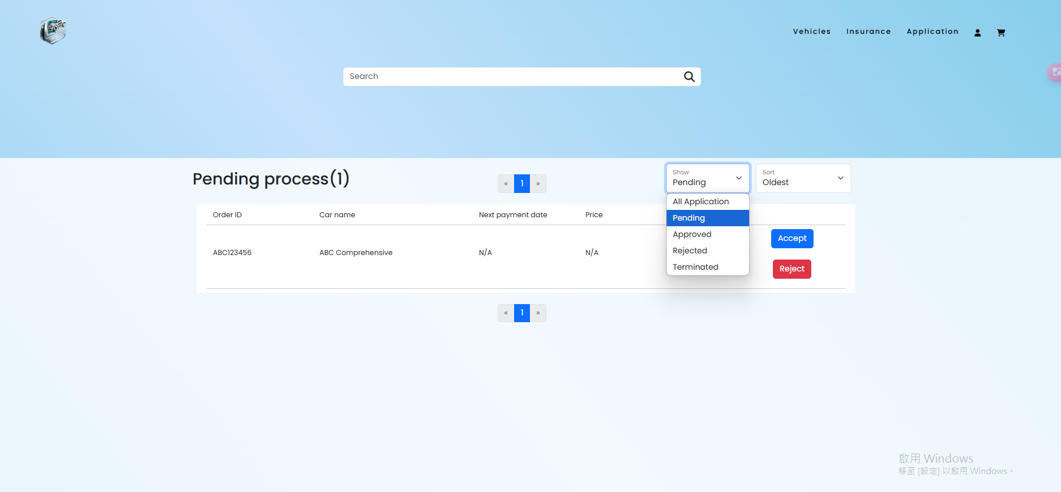

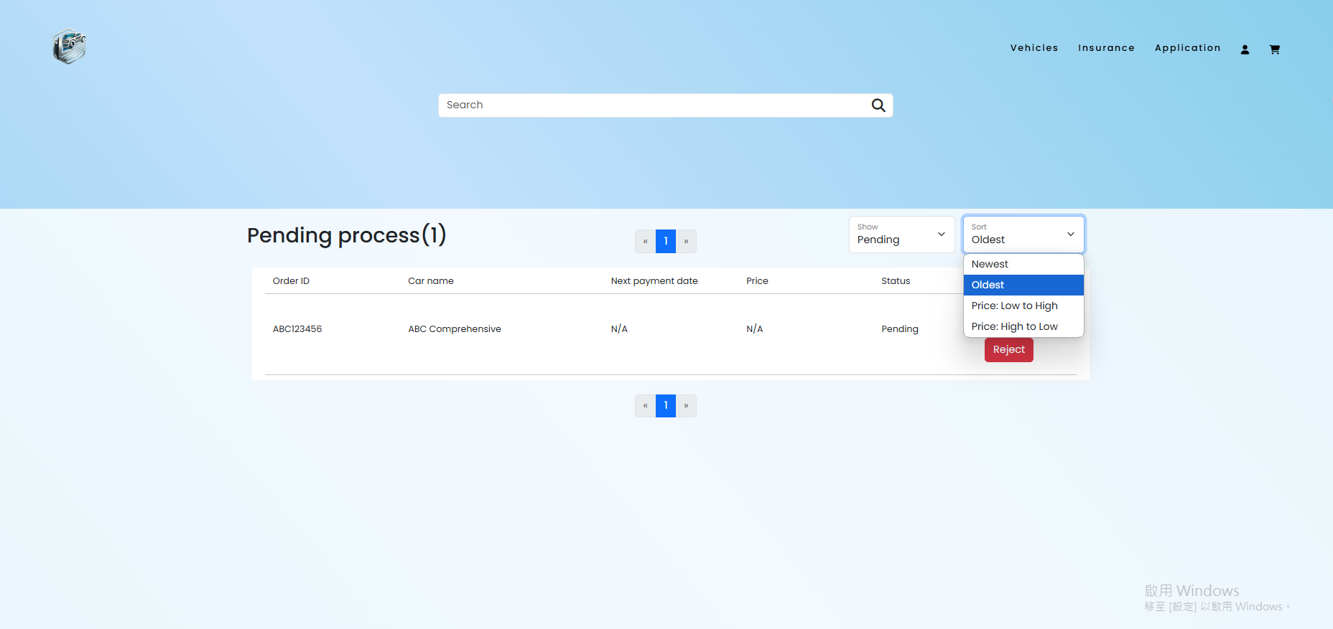

The **vehicle listings** are clearly displayed with **images**, **names**, **prices**, and key details. This ensures that the user can quickly scan the options and make a decision.

The layout uses a **grid system** to organize the products, ensuring that the information is well-structured and easy to navigate.

**Consistency**

The design uses consistent design elements such as buttons, fonts, and colors across all vehicles, creating a familiar and predictable environment for the user

**Recognition Over Recall**

The Order details are clearly displayed, with recognizable images and text labels for easy identification, allowing users to quickly recognize what they are looking for without needing to recall details

**Aesthetic and Minimalist Design**

The layout is clean, simple, and aesthetically pleasing. It avoids unnecessary elements that could overwhelm the user, focusing on the key features (e.g., product images, prices, and CTA buttons)

## Insurance System

### Customer

#### Index.html

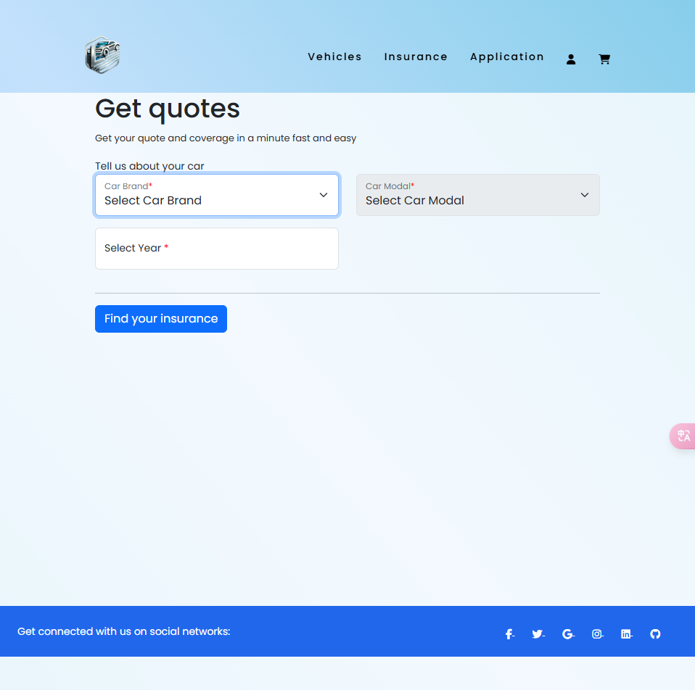

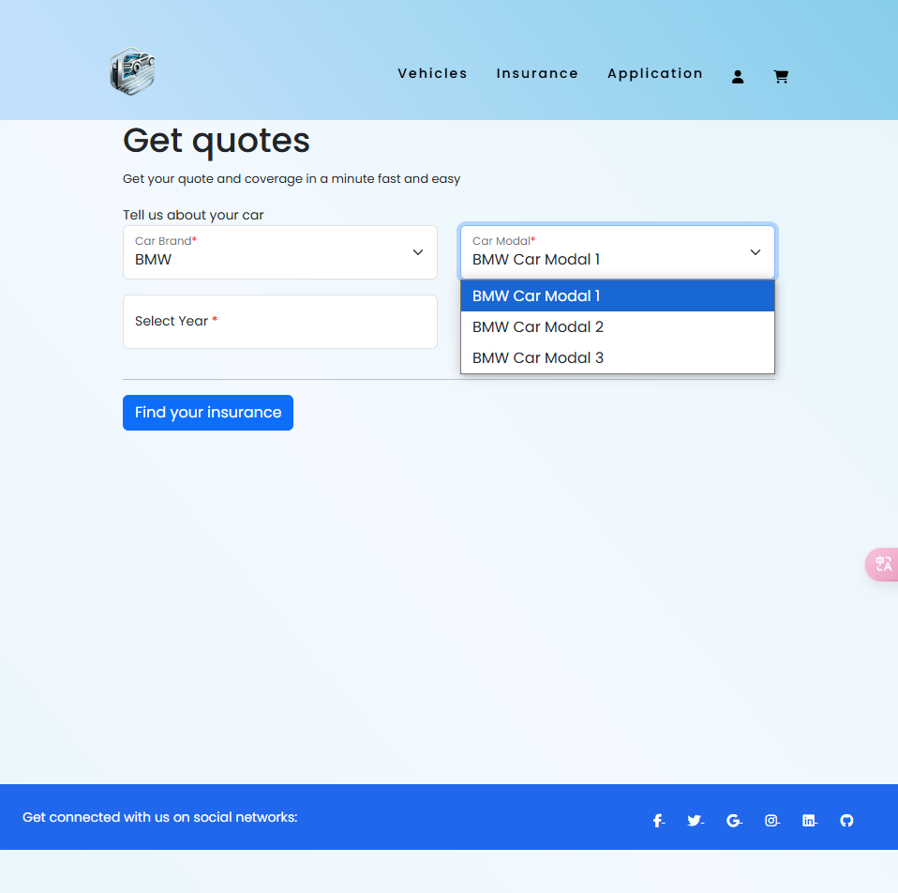

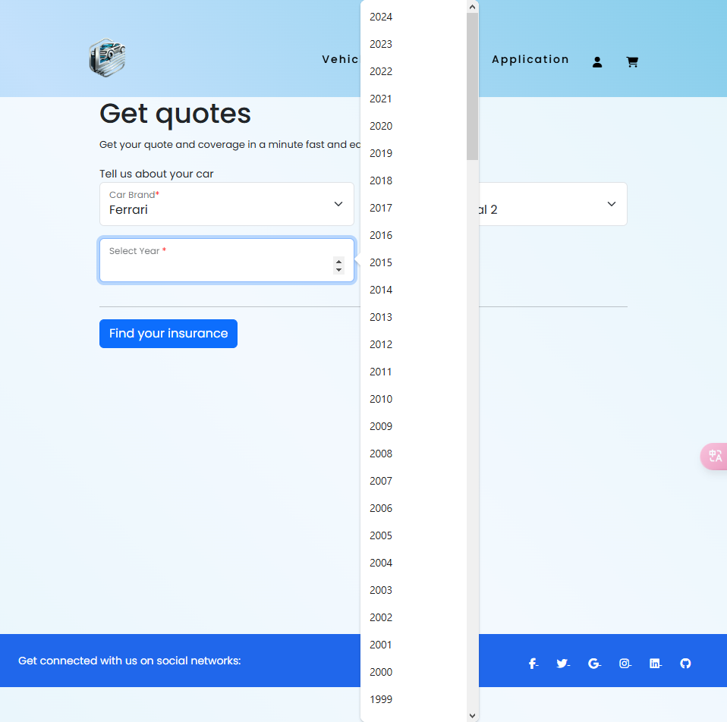

* User-Centered Design: The design adopts a user-centered approach by allowing users to select their car brand, model, and year using dropdown menus. This organization reflects an understanding of user needs, as it simplifies the process of providing relevant information for insurance quotes. By prioritizing user tasks, the design minimizes cognitive load and enhances usability.
* Feedback Mechanisms: Immediate feedback is crucial in HCI, and the design incorporates this by validating user input as they interact with the form. For example, if users fail to select a car brand or model, the system highlights the fields with a visual cue (e.g., adding an "is-invalid" class). This feedback helps guide users to correct their actions, fostering a sense of control and improving the overall experience.
* Affordances and Signifiers: The design effectively utilizes affordances and signifiers to indicate how users should interact with the interface. The dropdown menus for car brands and models are clearly labeled, making it obvious to users that they should click to make selections. This clarity is vital for reducing confusion and ensuring users understand how to navigate the system.
* Error Prevention and Recovery: The design incorporates features that help prevent errors by ensuring all required fields are filled out correctly before submission. If any fields are left empty, users are prompted with a modal alert informing them to complete all necessary fields. This proactive approach to error handling aligns with HCI principles, as it minimizes the chances of users encountering frustrating error messages after submission.
* Visual Hierarchy: The layout leverages visual hierarchy to prioritize important elements, such as the "Submit" button and input fields. By using size, color, and spacing effectively, the design ensures that users can easily identify and focus on key components needed to complete their insurance inquiries. A well-established visual hierarchy can significantly enhance the usability of the interface.

#### Find_insurance

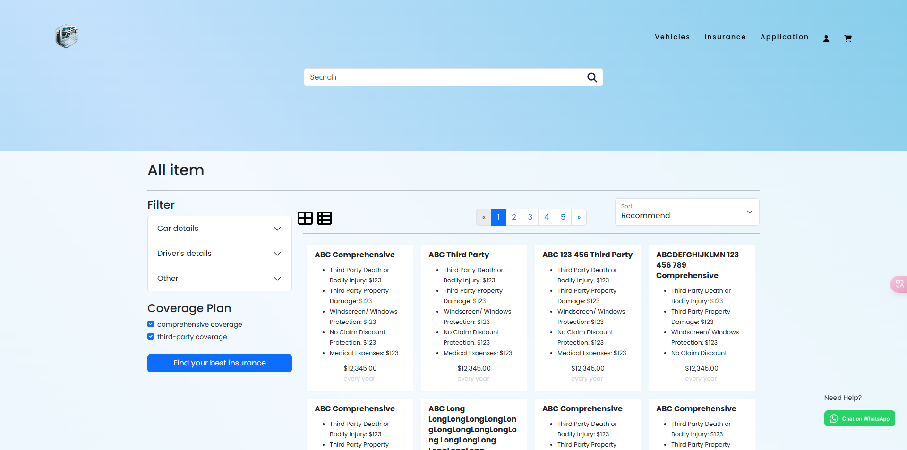

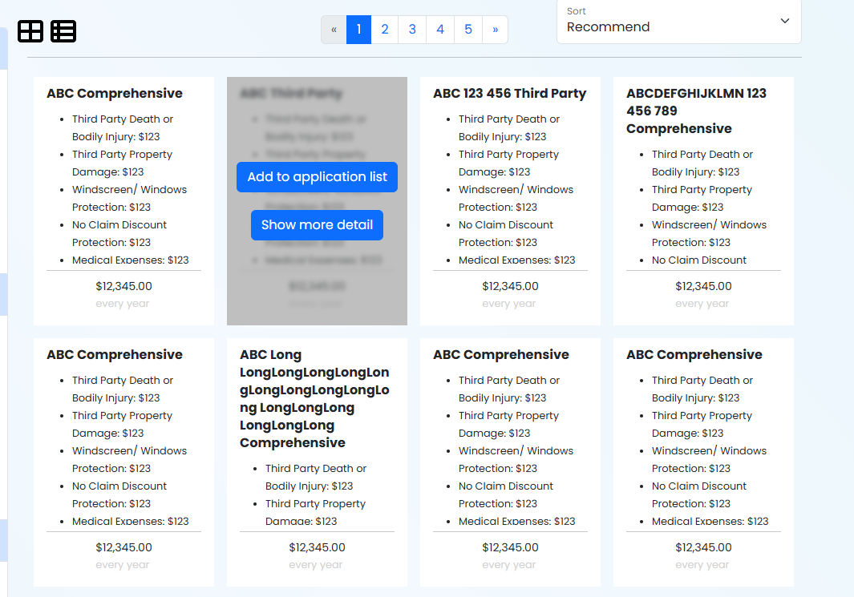

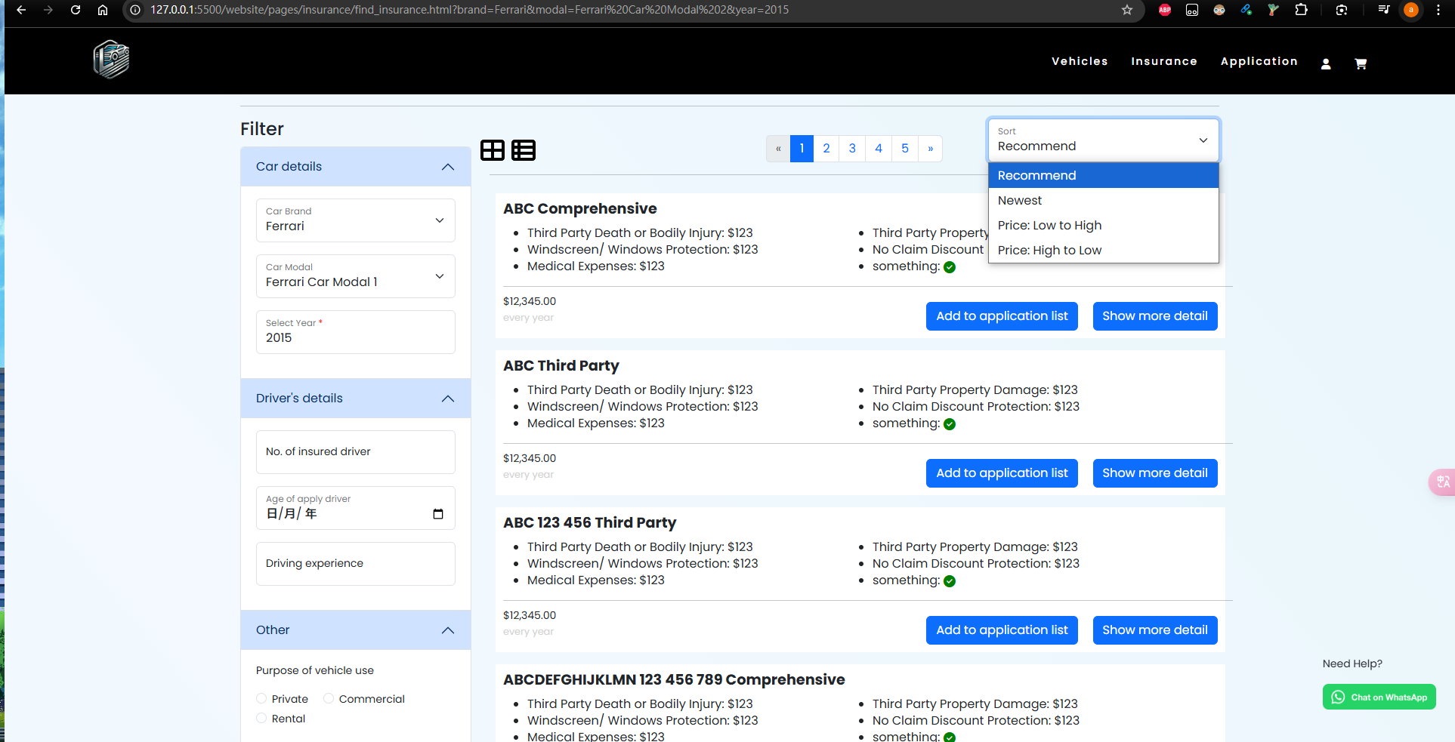

* User-Centered Design: The webpage is designed with the user in mind, allowing for a straightforward process to select a car brand, model, and year. This aligns with the HCI principle of user-centered design, which emphasizes creating interfaces that cater to the needs and tasks of users. By pre-populating the form fields with data received via the GET method (implement through js) (e.g., ?brand=Ferrari&modal=Ferrari%20Car%20Modal%202&year=2015), the design helps users quickly find relevant insurance information without unnecessary steps. The inclusion of sorting options enables users to quickly organize insurance products based on their preferences, such as price or newest listings. This aligns with HCI principles that emphasize designing for user tasks, making it easier for users to find relevant information efficiently. Supports switching between cell view and list view, providing different visual experiences according to users' personal preferences. In some cases, users may prefer to view information in list form for more detail, while in other cases they may prefer to view it in grid form to compare options more quickly. This flexibility aligns with HCI’s usability principles, allowing users to choose the view that best suits their needs.
* Feedback Mechanisms: The design incorporates immediate visual feedback when users perform actions like sorting or filtering. For example, when a user selects a sorting option, the page can dynamically update to reflect the choice. This responsiveness keeps users informed about the system's state and reassures them that their actions have been recognized.
* Affordances and Signifiers: The design makes effective use of affordances and signifiers, which help users understand how to interact with the interface. For example, the dropdown menus for selecting car brands and models visually indicate that they can be clicked and expanded. This clarity is crucial in reducing user confusion and ensuring that they can navigate the system intuitively.

#### Insurance_detail

Zoom to 67%

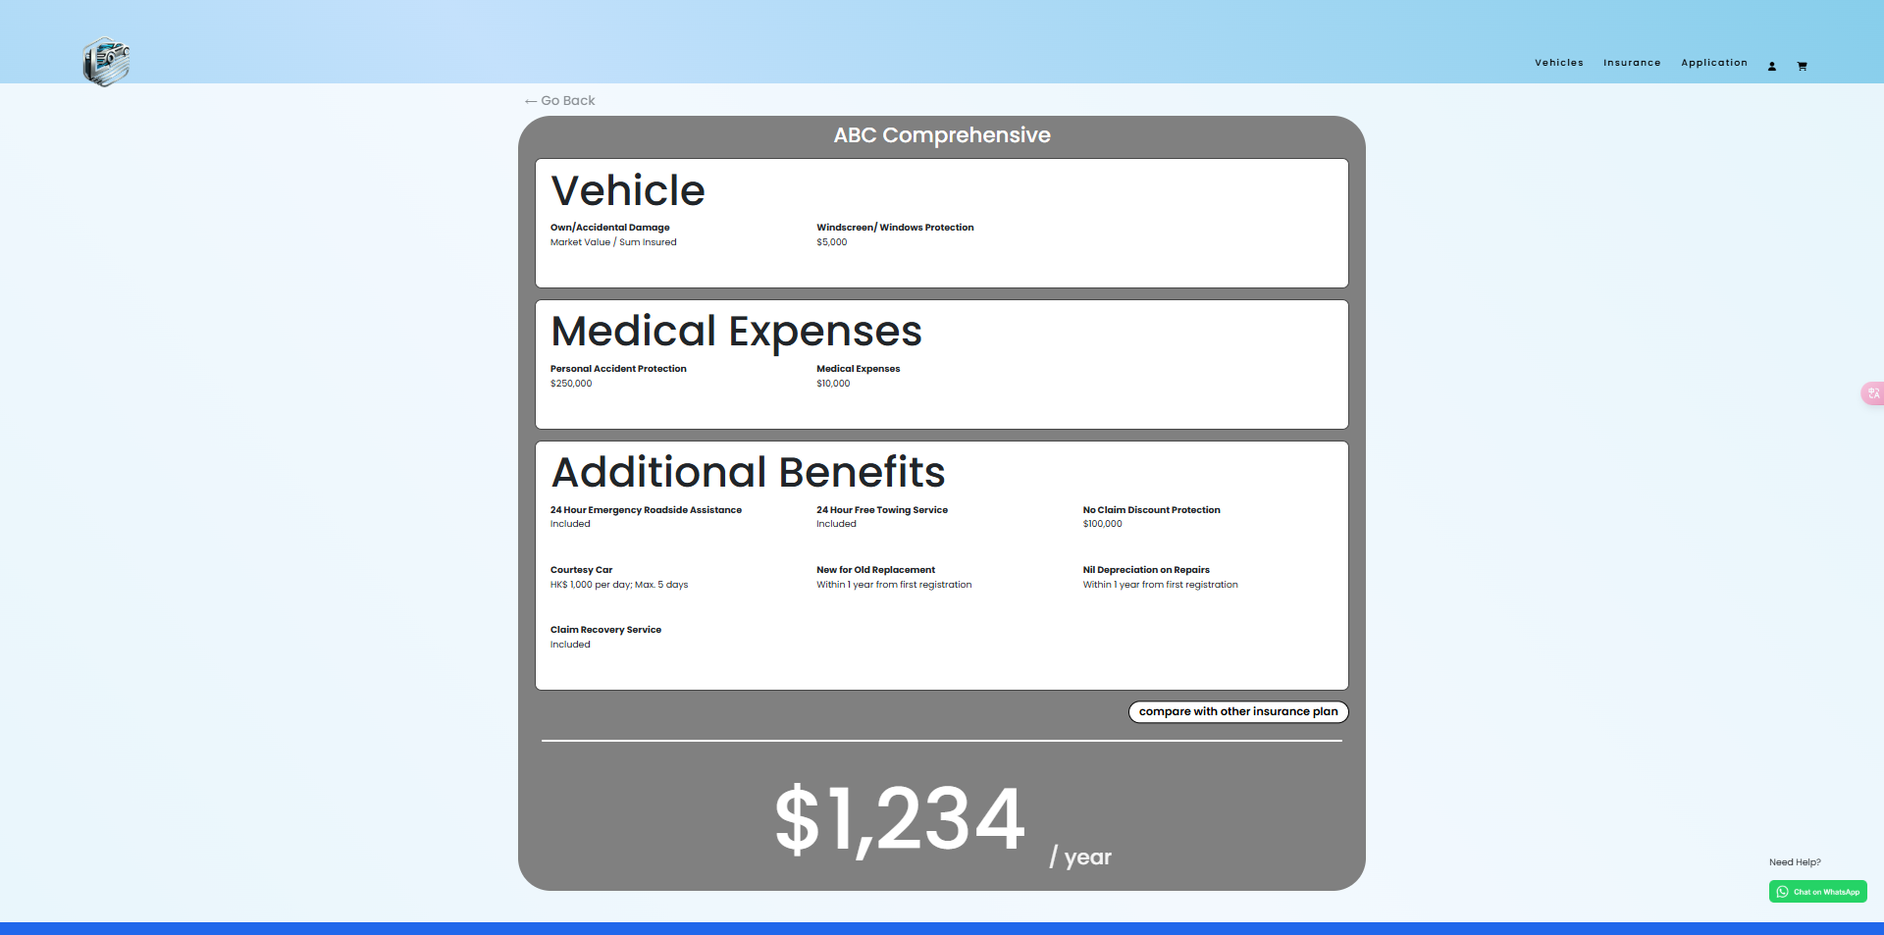



* Usability and User-Centered Design: The insurance_detail page is designed with usability in mind, ensuring that users can easily access and understand the details of their insurance options. The layout is straightforward, presenting critical information clearly, which is essential for user satisfaction. HCI emphasizes the importance of creating systems that meet users' needs, and this design achieves that by providing a concise overview of insurance details.
* Visual Hierarchy: The layout of the insurance_detail page employs visual hierarchy to guide users' attention to the most important information, such as coverage details and pricing. By utilizing size, color, and spacing effectively, the design ensures that users can quickly identify and focus on key components, which is crucial for making informed decisions.

#### Compare

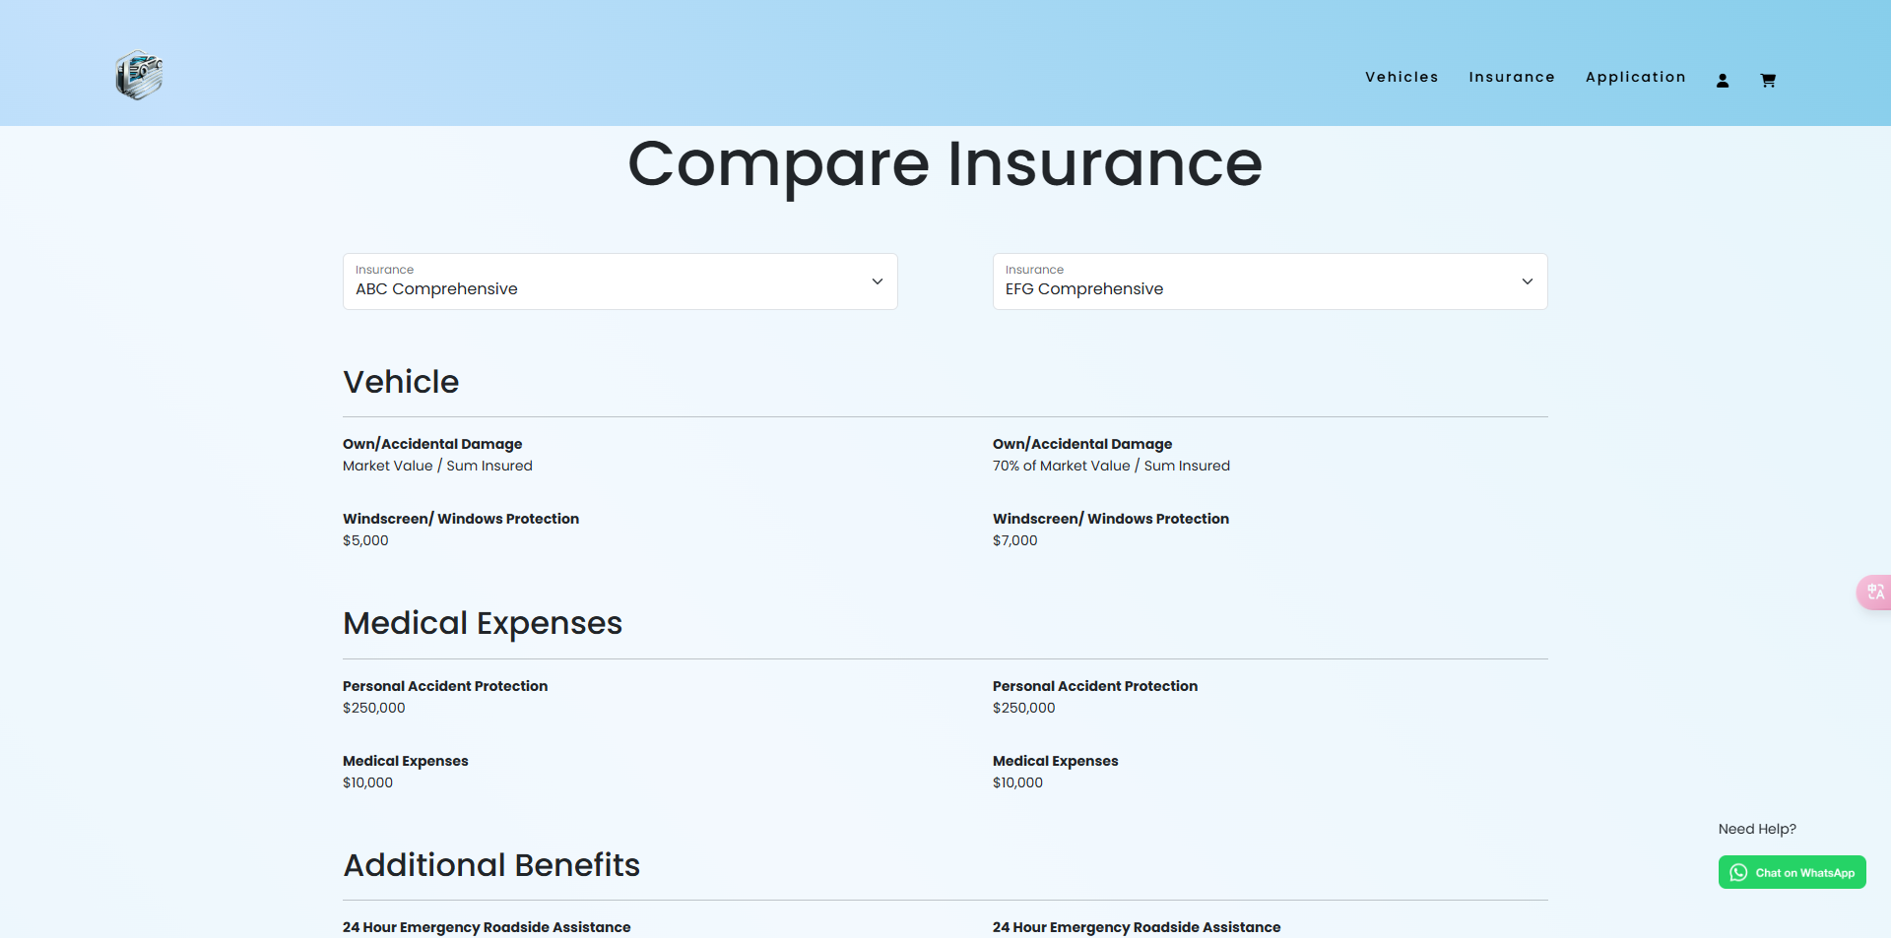

* User-Centered Design: The compare.html page is structured to prioritize user needs by allowing users to easily compare different insurance options. This organization reflects an understanding of user tasks, as it simplifies the process of evaluating various policies side by side. By presenting the information in a clear and concise manner, users can make informed decisions quickly.
* Feedback Mechanisms: Immediate feedback is crucial in HCI, and the design includes features that inform users about their actions. For instance, when users select different insurance plans to compare, the interface can dynamically update to reflect their choices. This responsiveness keeps users engaged and reassured that their interactions are recognized.
* Visual Hierarchy: The layout of the compare.html page employs visual hierarchy to guide users' attention to the most important information, such as the types of coverage and associated costs. By using size, color, and spacing effectively, the design ensures that key components stand out, making it easier for users to process and compare options.

#### Input_information

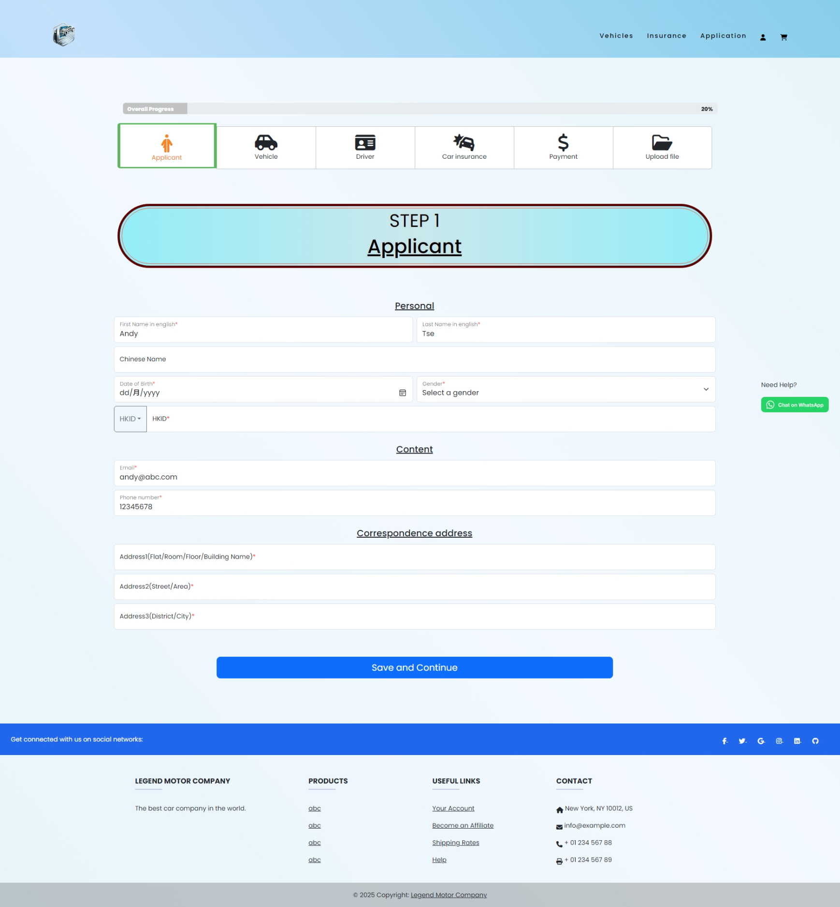

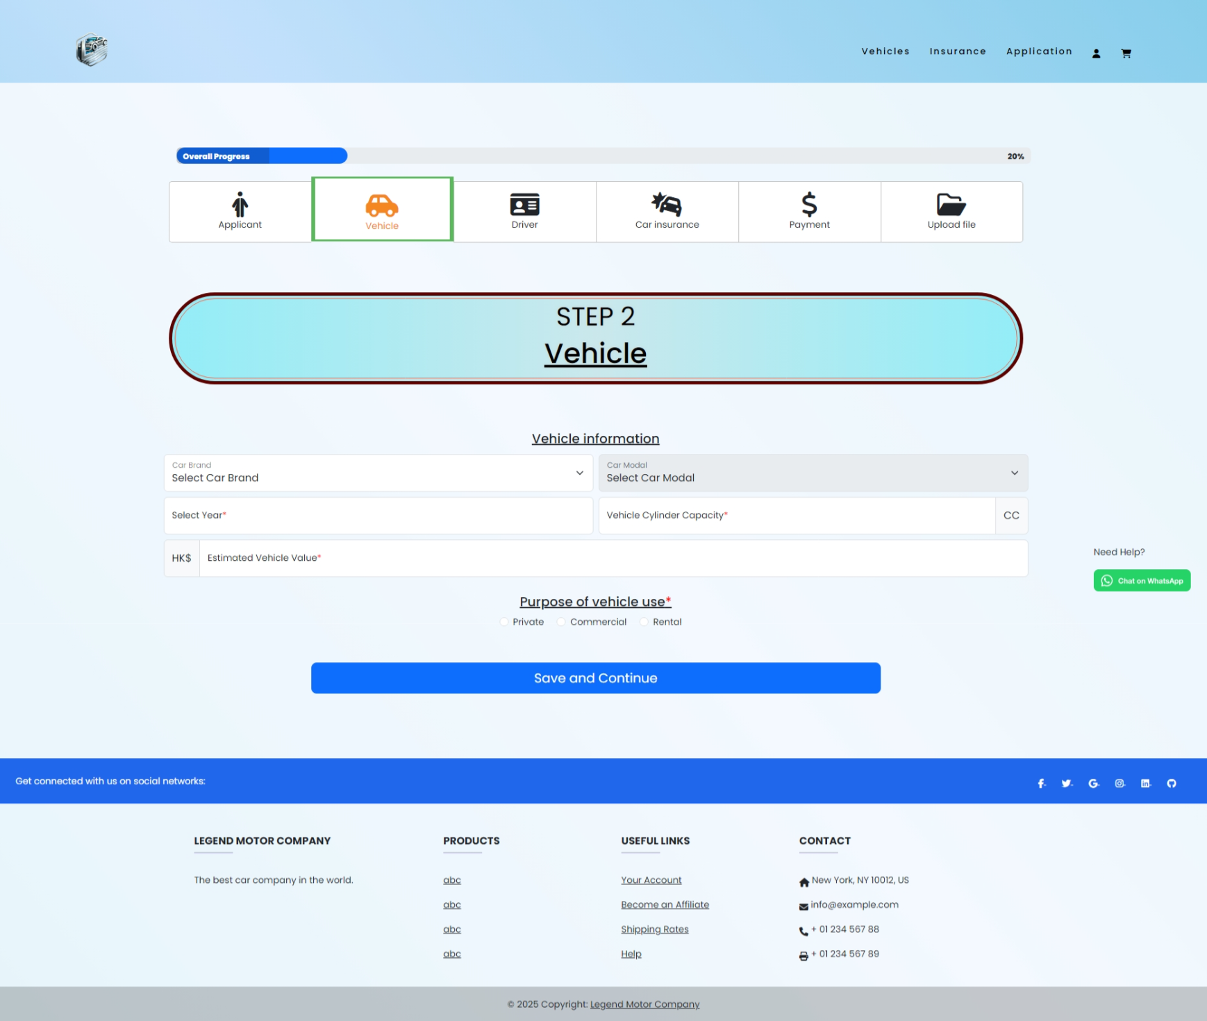

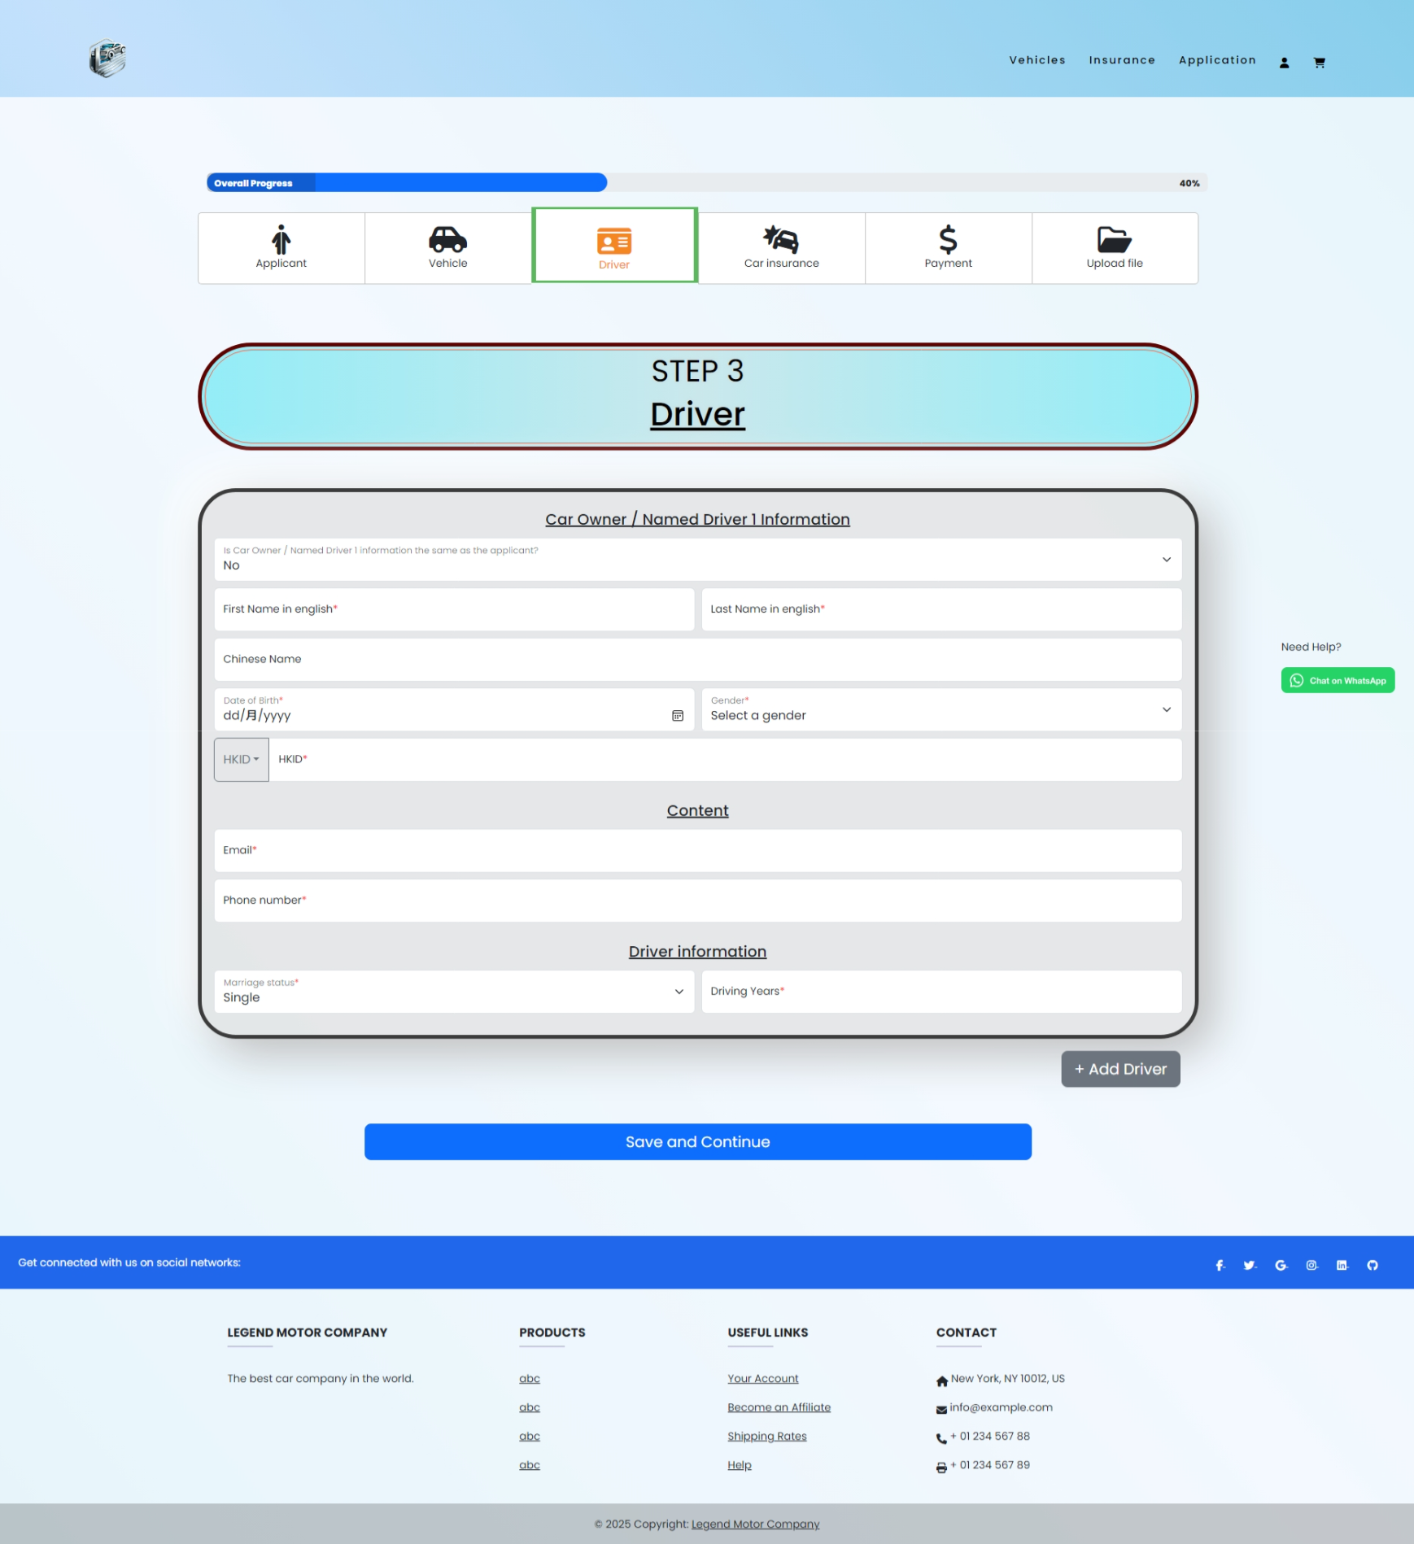

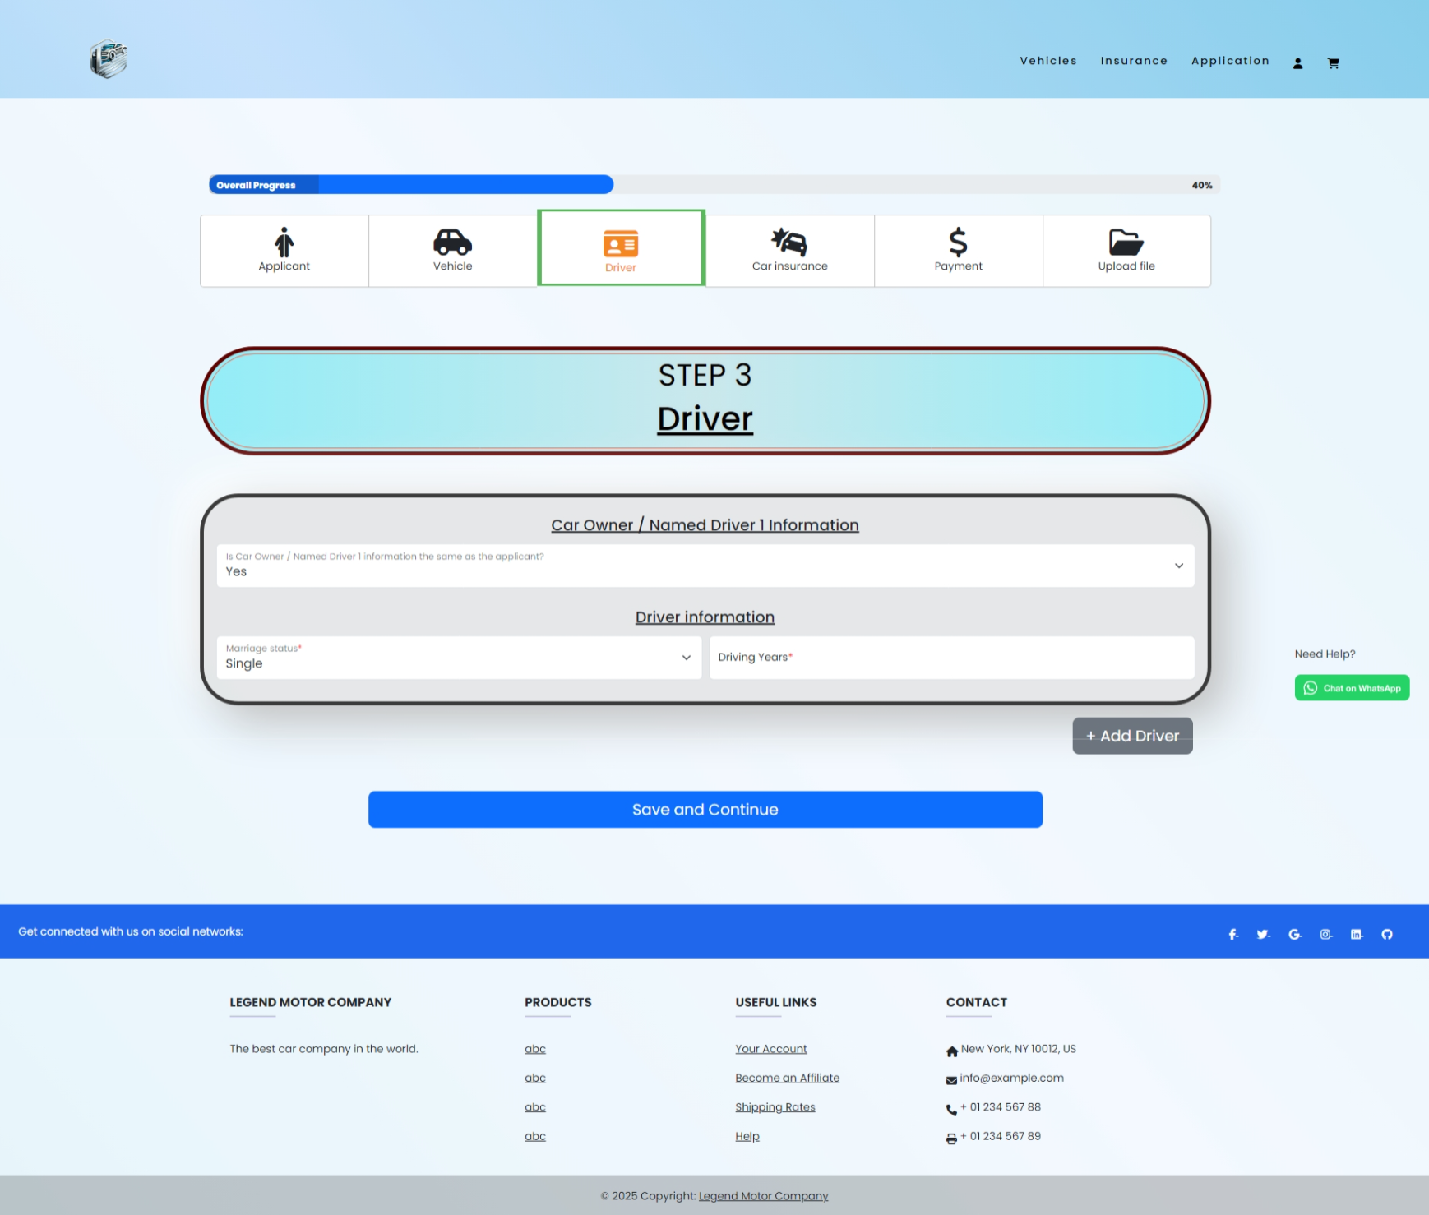

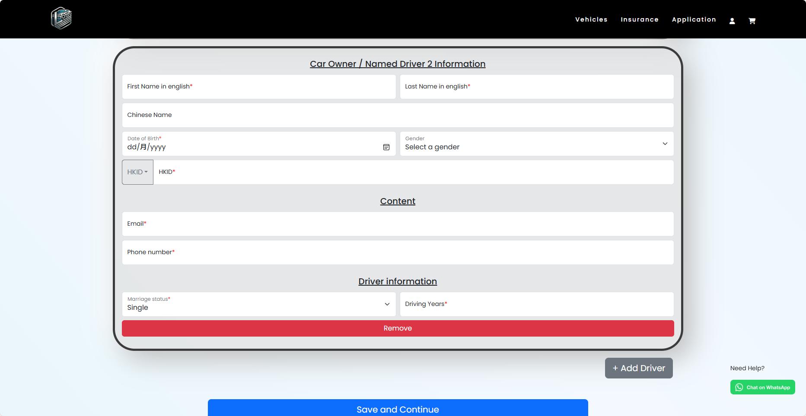

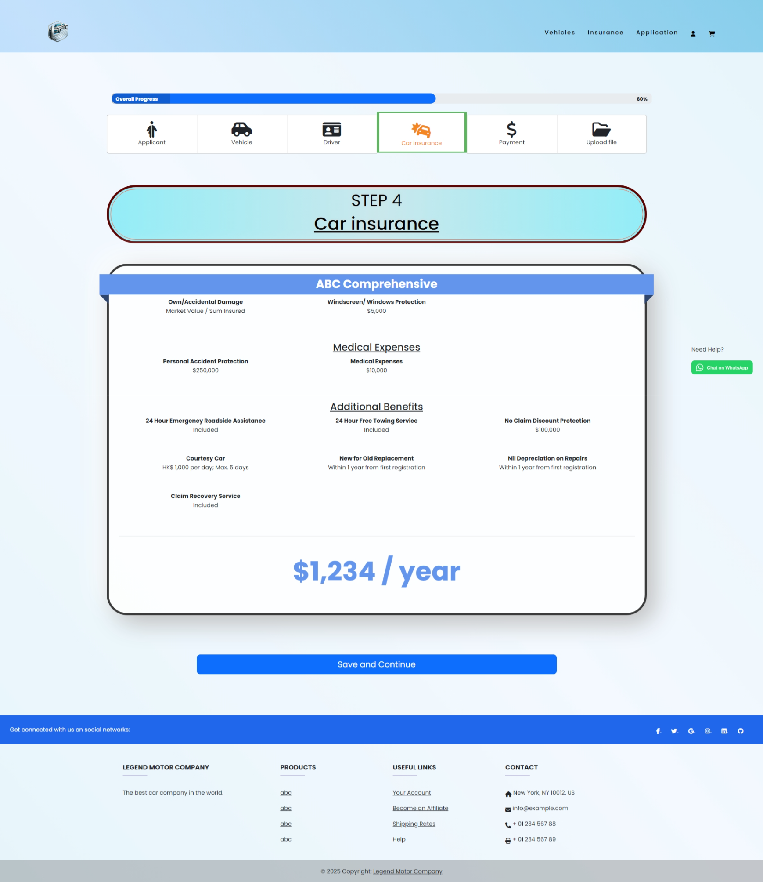

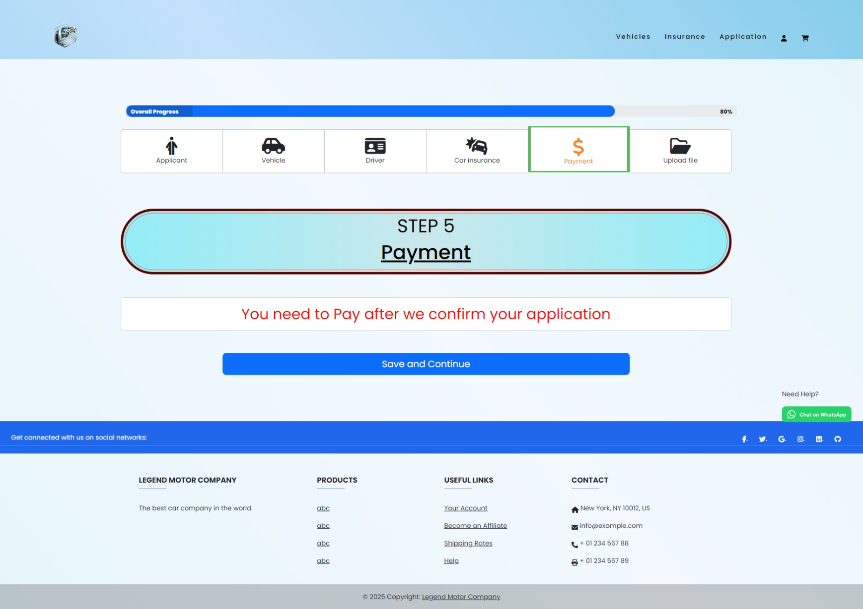

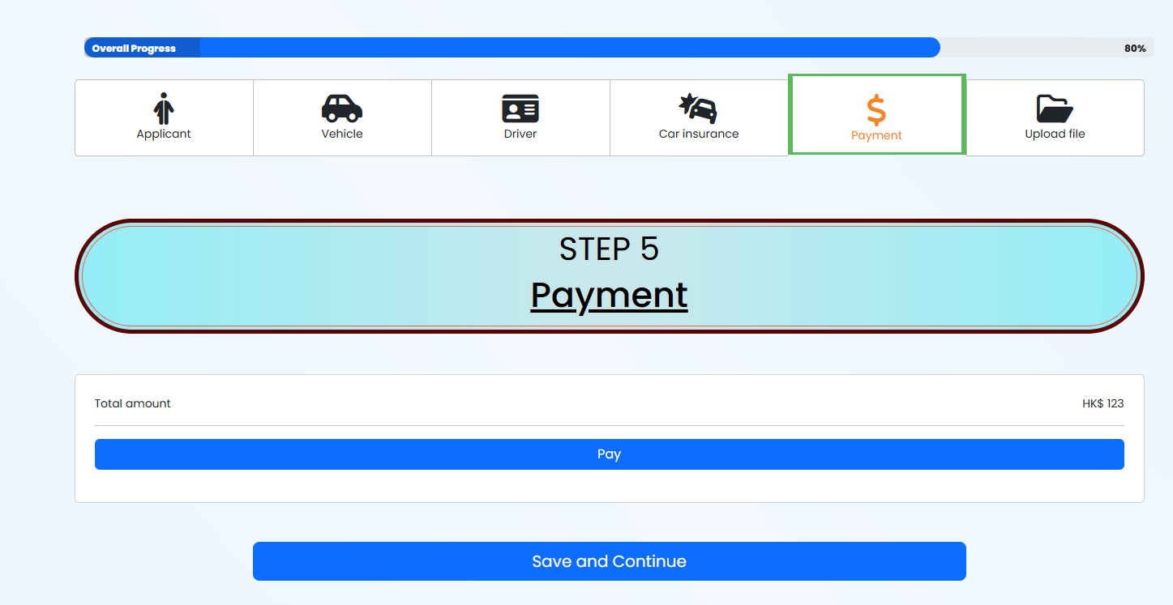

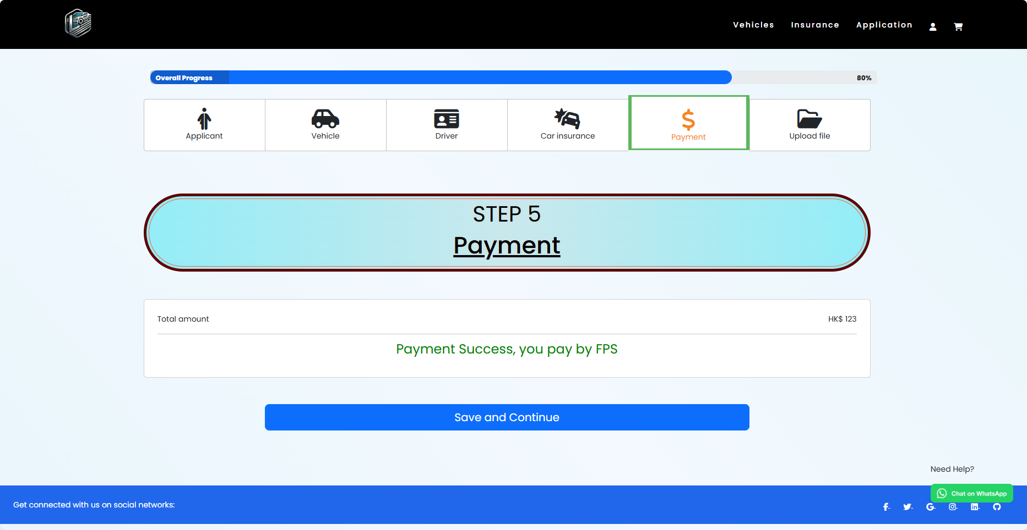

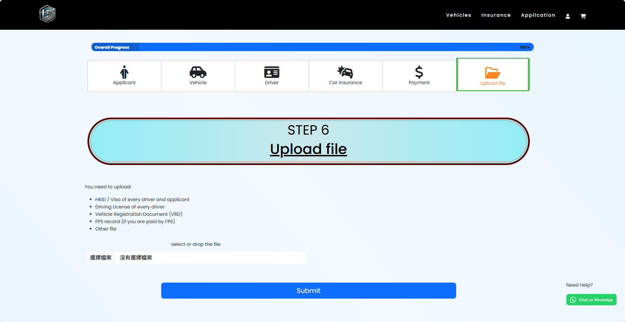





* Usability: The design prioritizes usability by providing a clear and logical structure for users to input their information. Each section is labeled appropriately, which helps users quickly understand what details are required. This aligns with HCI principles that focus on making interfaces intuitive and easy to navigate.
* Affordances and Signifiers: The design effectively employs affordances and signifiers to indicate how users should interact with various elements. Input fields, dropdown menus, and buttons are visually distinct and labeled clearly, making it apparent to users how to engage with them. This clarity is essential for reducing cognitive load and ensuring users can navigate the system effectively.
* Error Prevention and Recovery: The design includes features to help prevent errors, such as input validation that ensures users provide the correct format for phone numbers or email addresses. Additionally, when errors occur, the system provides clear instructions on how to rectify them, which is in line with HCI principles that advocate for minimizing user frustration and supporting error recovery.
* Visual Hierarchy: The layout utilizes visual hierarchy to guide users' attention to the most important information. For example, the use of font size and color effectively highlights required fields and action buttons, making it easier for users to focus on completing their tasks.
* Feedback and Communication: The system provides immediate feedback as users interact with it. For instance, upon completing a step, users receive visual cues and messages confirming their actions, which is crucial for keeping them informed about what’s happening. This reflects HCI's emphasis on the importance of feedback in maintaining a communicative interface.

#### Application_list

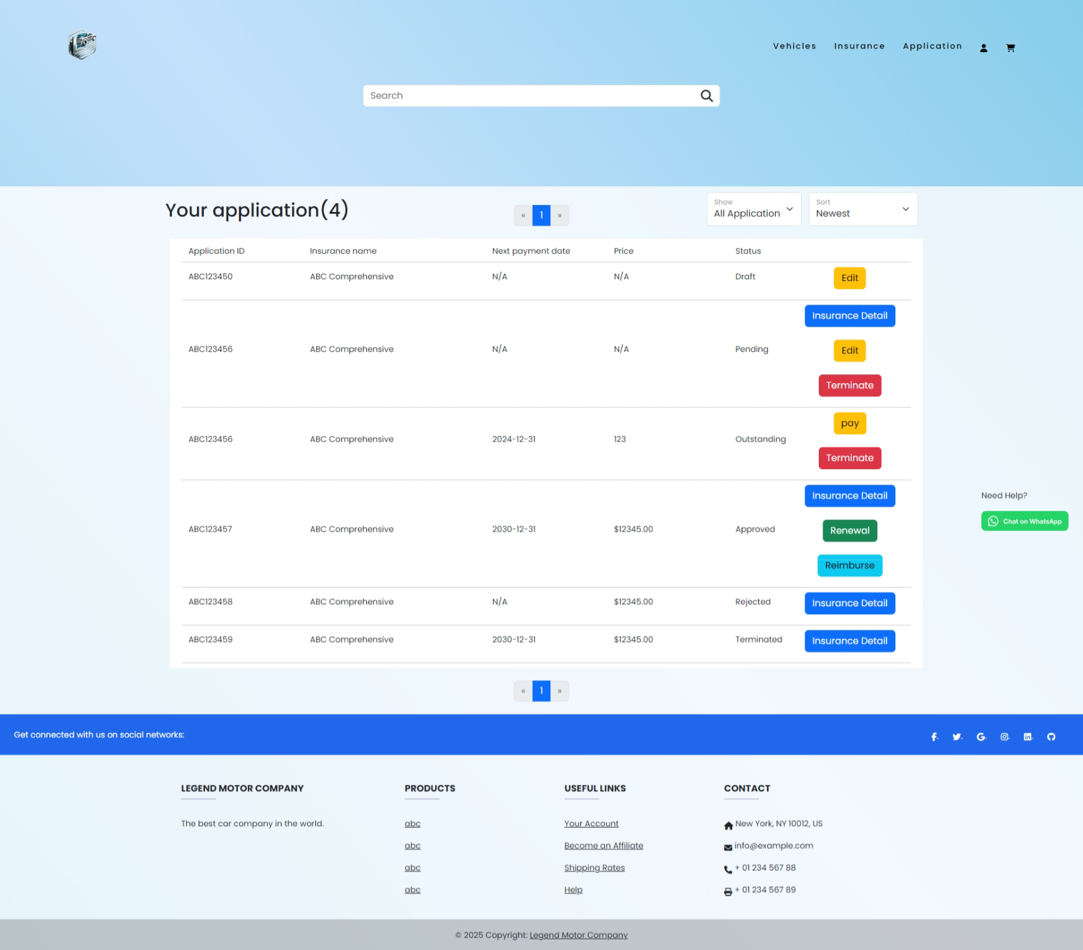

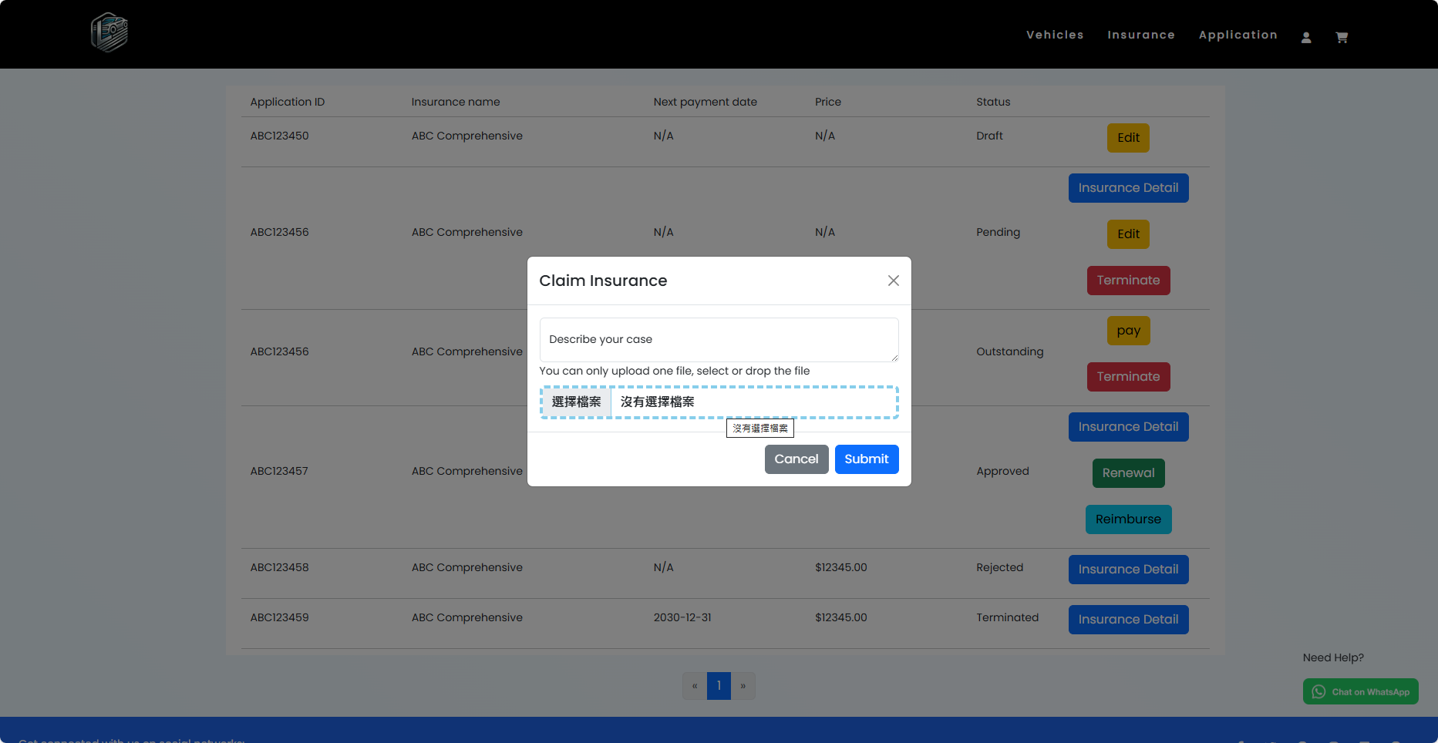

Usability: The application list page is designed with usability in mind, featuring a clear and organized layout that allows users to easily navigate through their insurance applications. The use of headings, filters, and clearly labeled buttons ensures users can find the information they need without unnecessary effort. This aligns with HCI principles that emphasize creating intuitive interfaces to facilitate user tasks.

Feedback Mechanisms: Effective feedback is crucial in HCI, and the design incorporates this by providing visual confirmation when users interact with elements. For example, when a user clicks on a button to view more details about an insurance application, they receive immediate feedback through a modal or a new page displaying the relevant information. This responsiveness keeps users informed and engaged, reinforcing their actions.

Affordances and Signifiers: The interface effectively uses affordances and signifiers to guide user interactions. Buttons such as "Add to application list" and "Show more detail" are visually distinct and labeled clearly, indicating their functionality. This clarity reduces user confusion and ensures that users can easily navigate the application list.

#### Insurance_information

Many things same with input_information, I will only show different part of them.

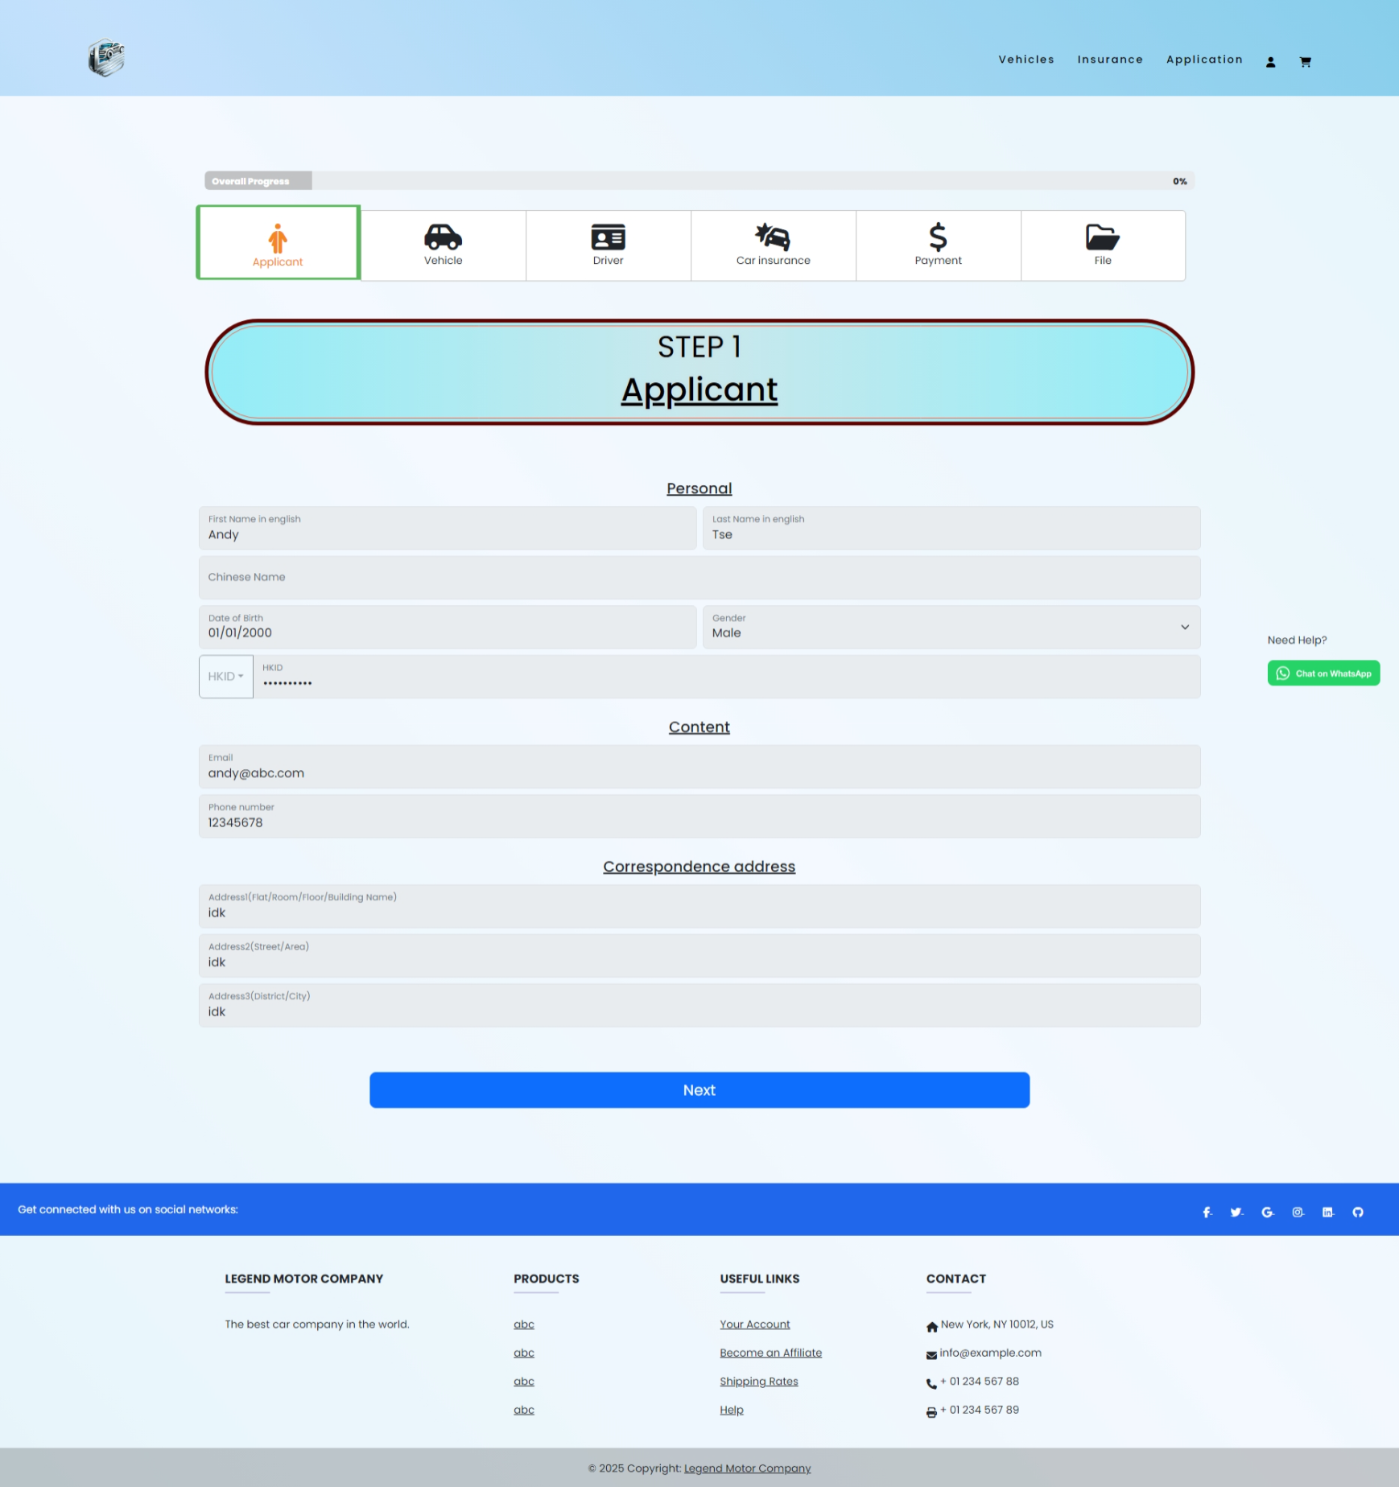

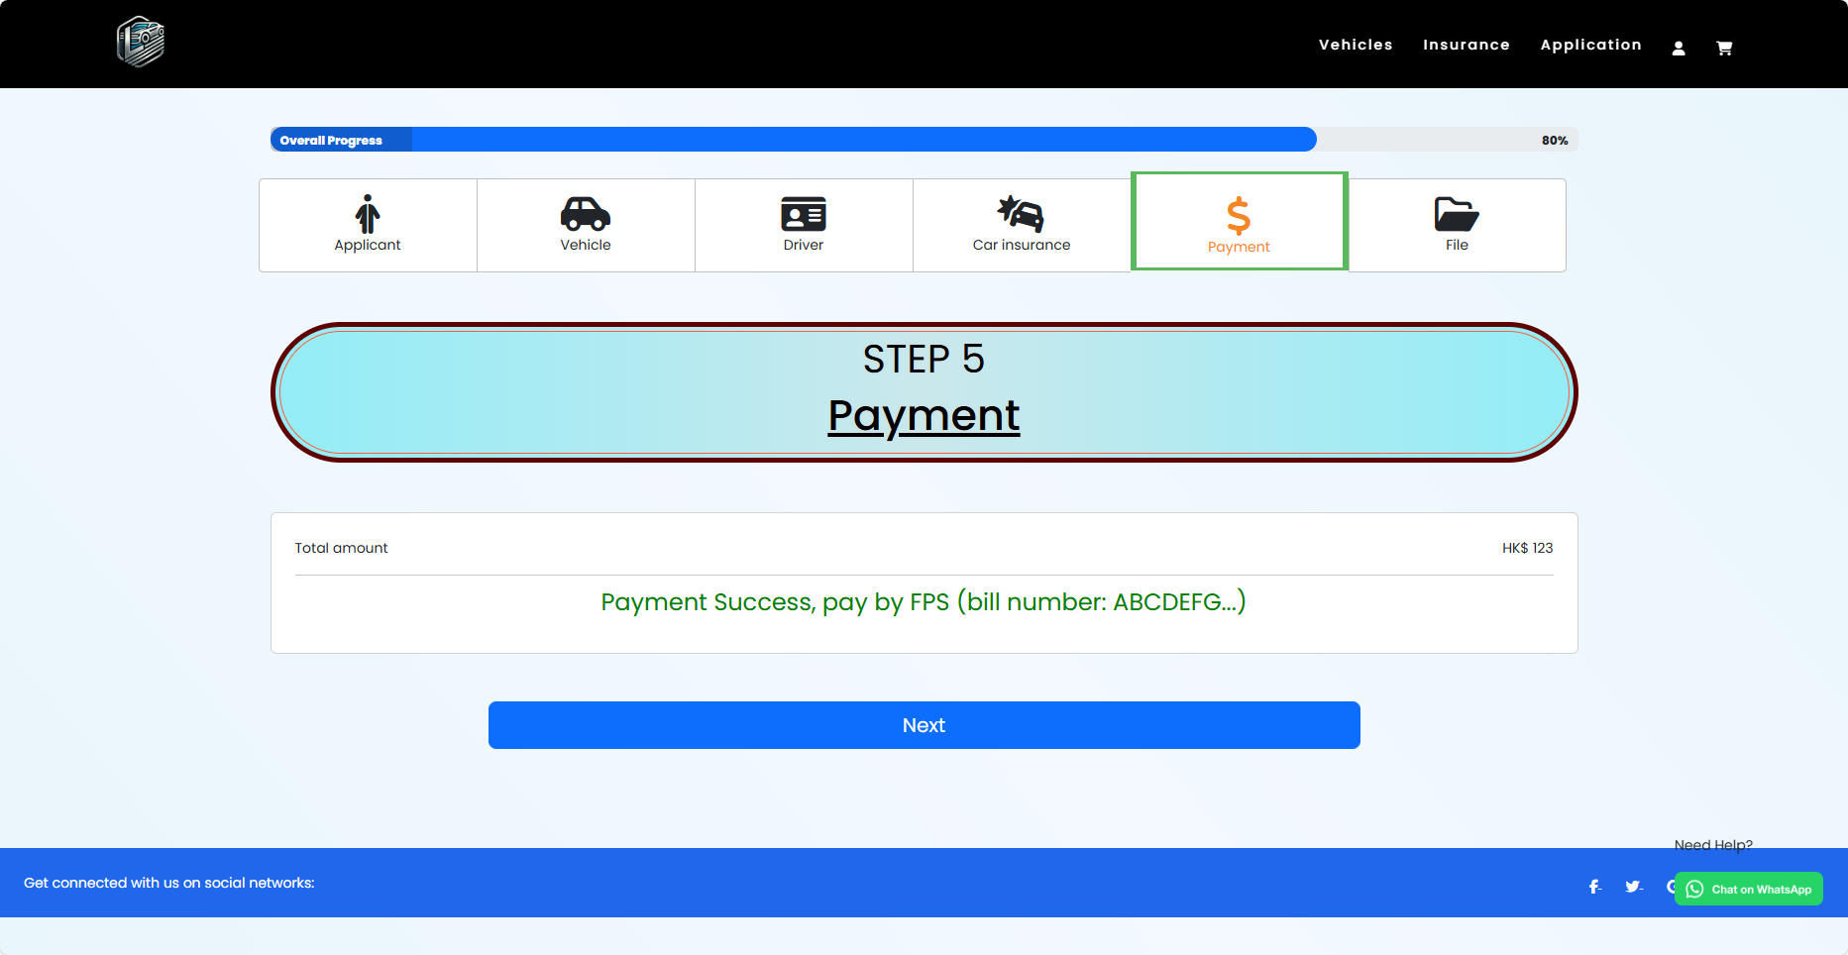

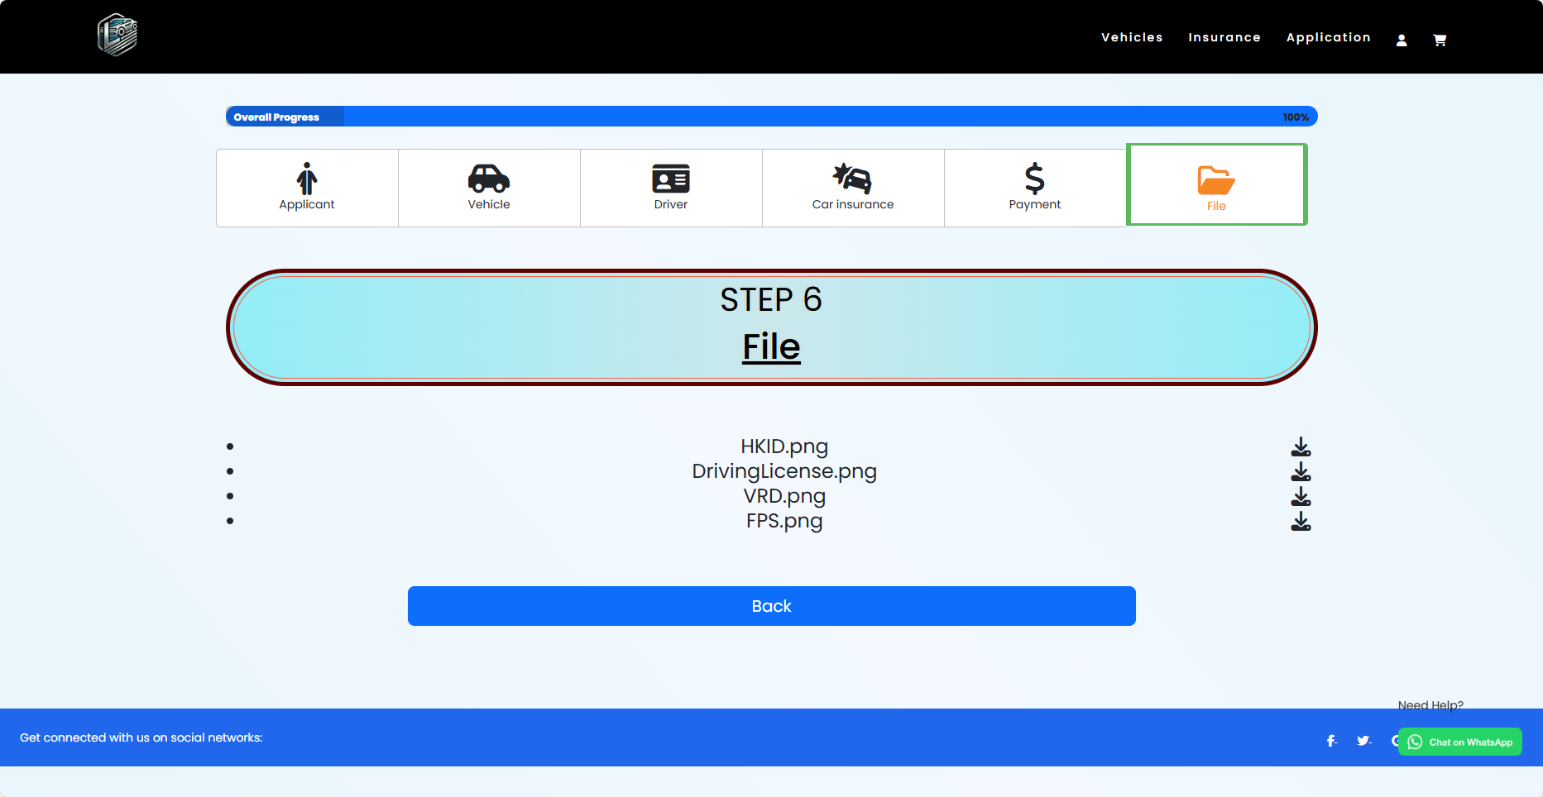

User-Centered Design: The layout is structured to prioritize user needs, presenting essential information in a clear and organized manner. Each section of the insurance details is clearly labeled, making it easy for users to find the information they need. This approach reflects HCI principles that emphasize designing systems based on user tasks and needs.

### Insurance Sale

#### Application_manae

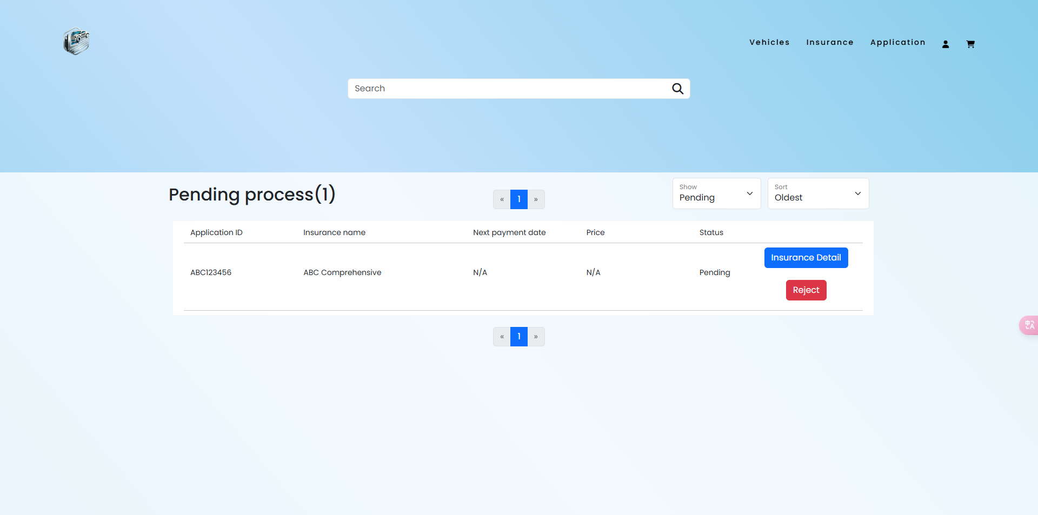

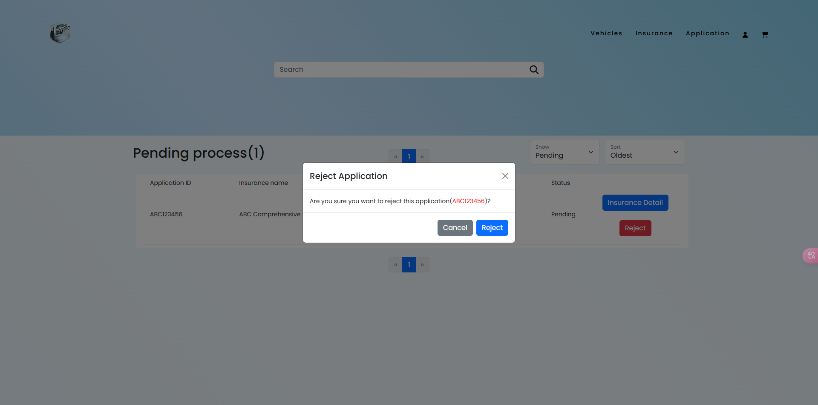

* Mental Models: The design takes into consideration the mental models users build based on their previous experiences. Users expect to find certain functionalities easily. For instance, the clear labeling of buttons (like "Reject" and "Confirm") aligns with users' expectations of what these actions entail, thereby facilitating intuitive navigation.
* Affordance: The buttons and interactive elements are designed with affordance in mind. For example, the buttons for rejecting an application and confirming actions are visually distinct and positioned prominently, indicating their functions effectively. This allows users to understand what actions they can perform without needing extensive instructions.
* Feedback: The design incorporates immediate feedback mechanisms. When a user clicks the "Reject" button, a modal dialog appears confirming the action, which reinforces the user's decision-making process. This feedback is crucial as it informs users of the consequences of their actions, aligning with the principle of providing clear and timely feedback.
* Consistency: The interface maintains consistency in design elements, such as colors and button styles, which helps users build familiarity and predictability with the application. For example, the use of a uniform color scheme and layout across various buttons and modals ensures that users can easily recognize and understand their functions.
* Content Organization: The organization of information within the application manages user expectations and supports efficient navigation. The use of sections, buttons, and modals to categorize actions (e.g., viewing insurance details, rejecting applications) reflects a thoughtful organizational scheme that aids users in finding the information they need quickly.
* Accessibility: The design considers accessibility by incorporating features such as clear button sizes and contrasting colors, which cater to users with varying abilities. For instance, the modal dialogs are structured to be easily readable and navigable, ensuring that all users can interact with the application effectively.

#### Insurance_information

Many things same with input_information, I will only show different part of them.

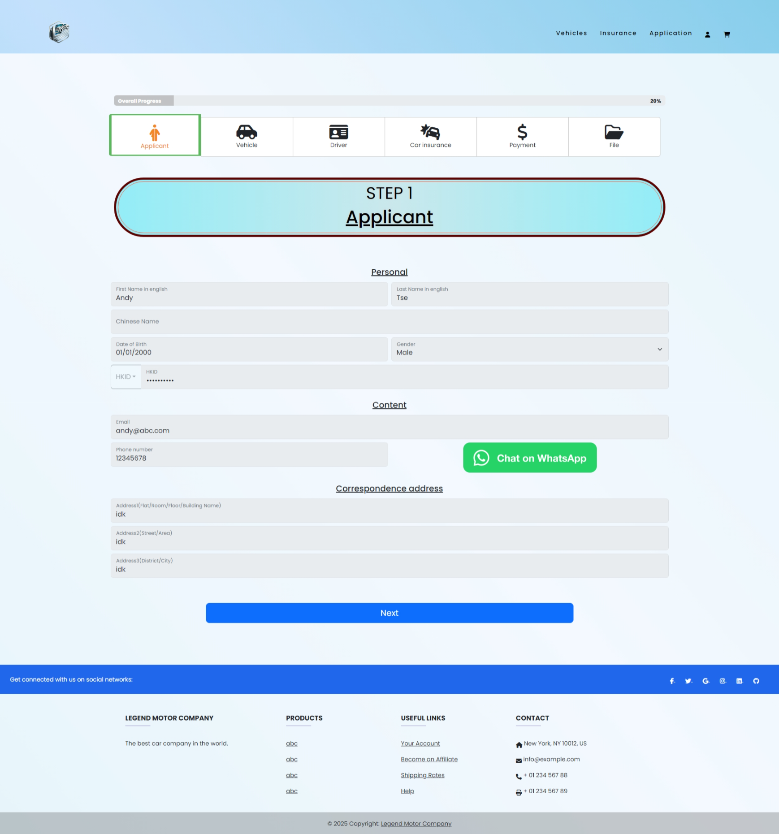

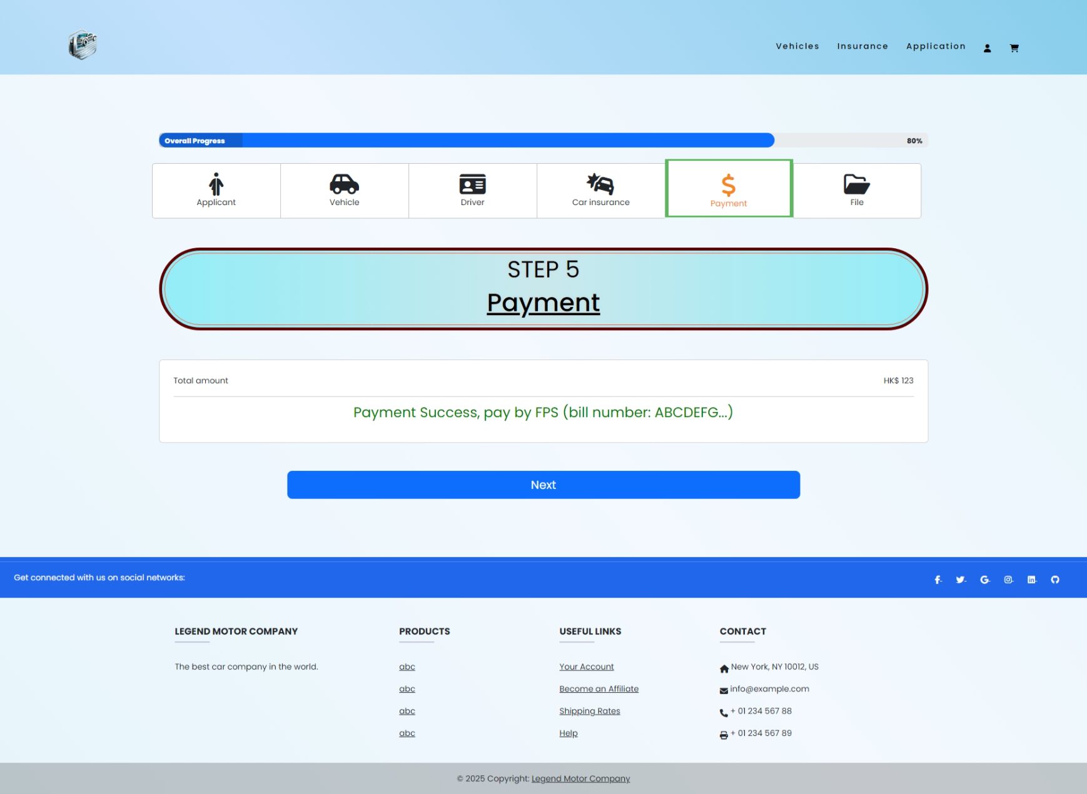

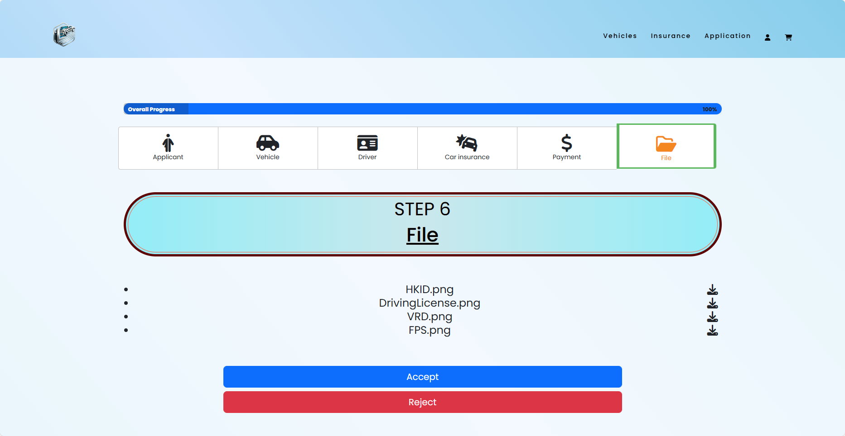

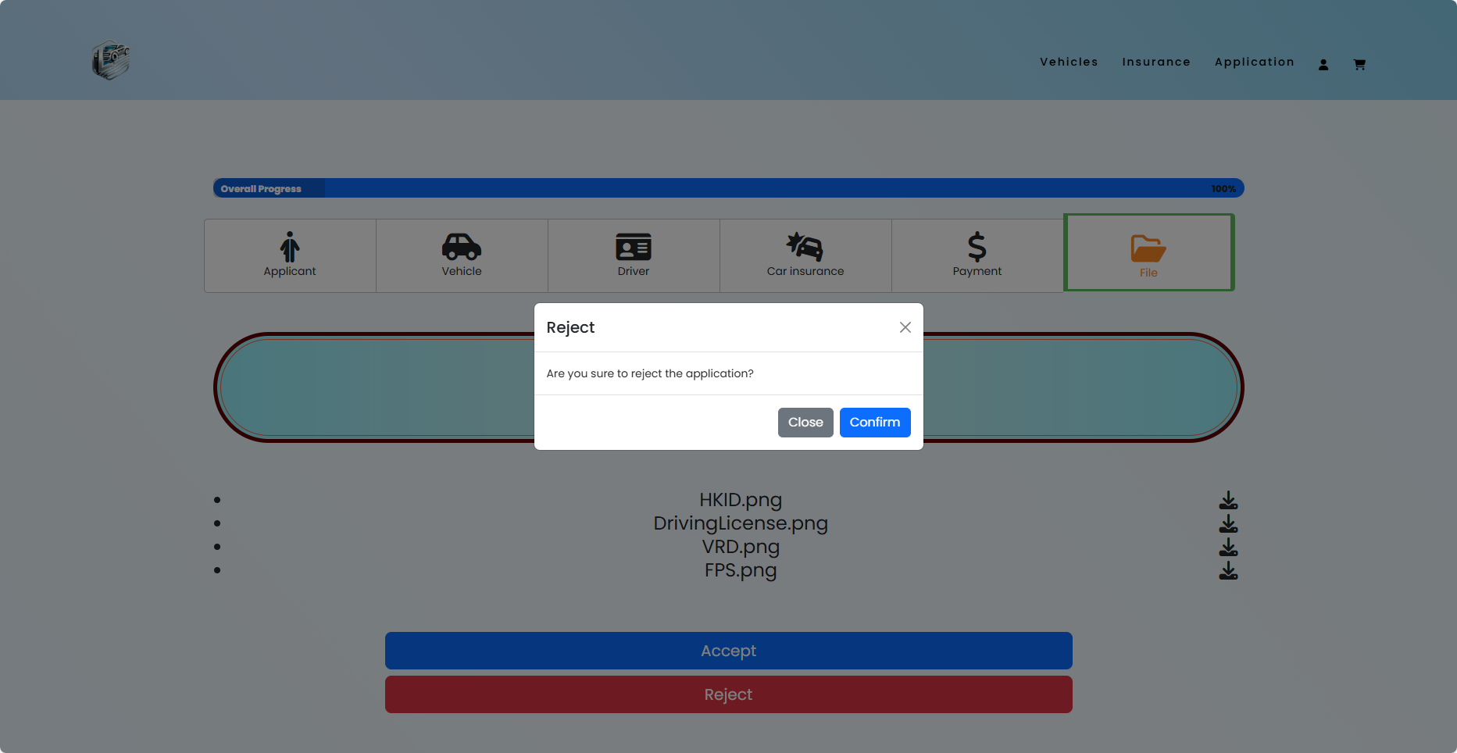

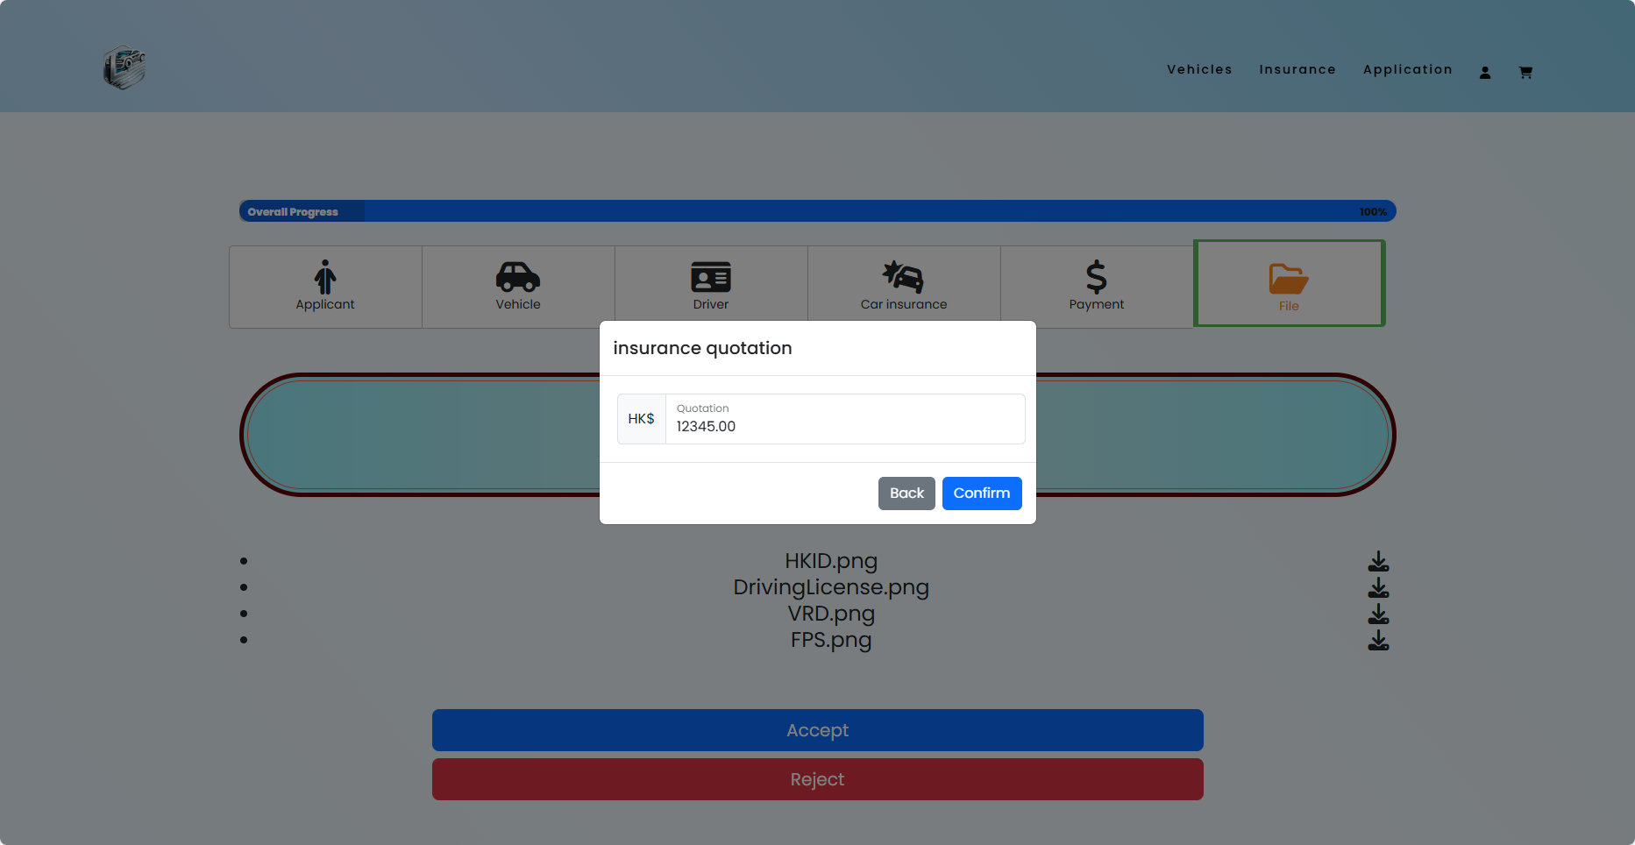

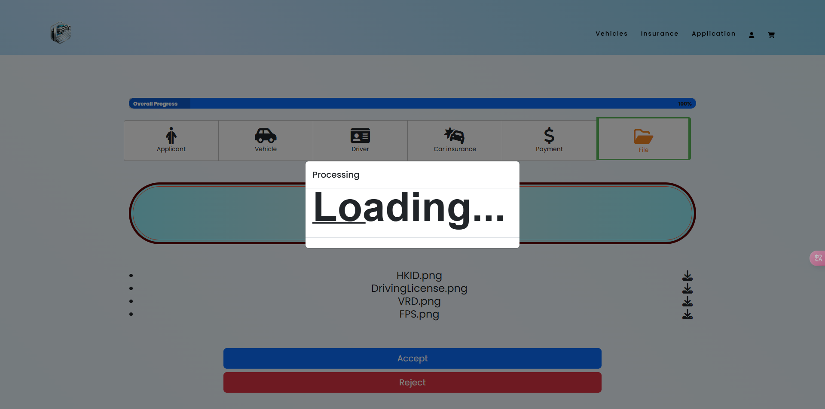

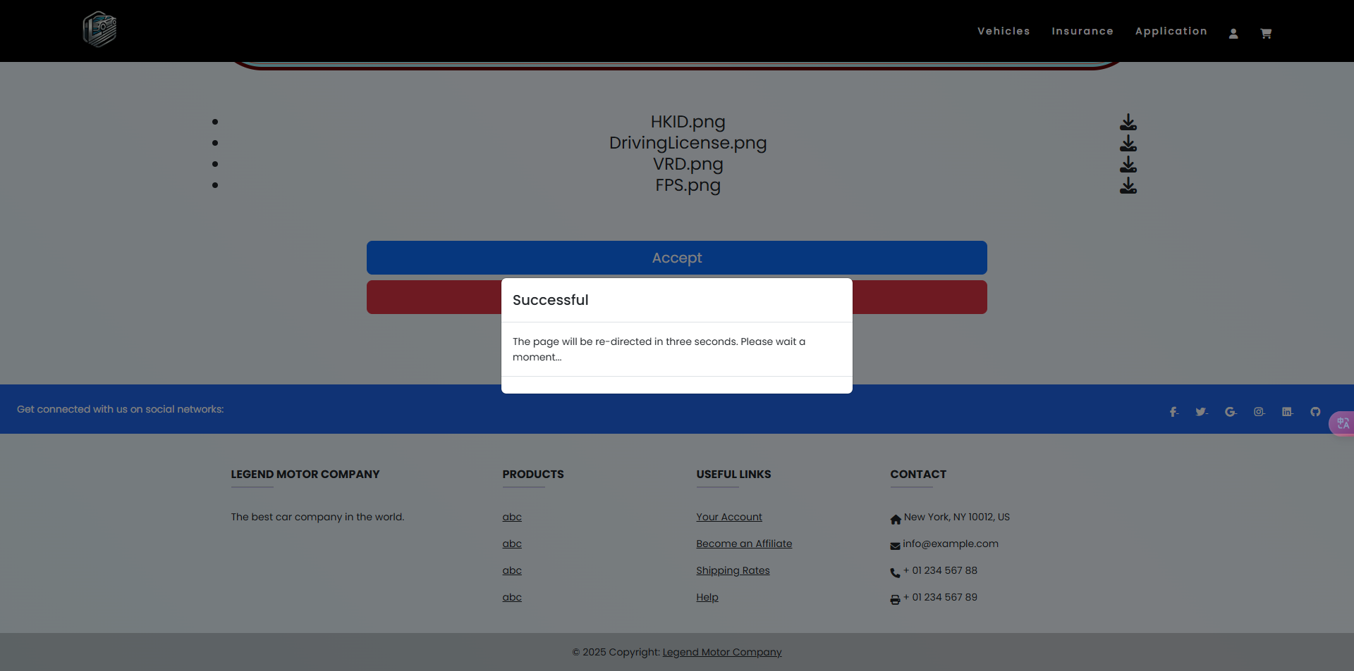

* Usability: The interface is designed to be user-friendly, ensuring that users can navigate through the application smoothly. Elements like forms for applicant, vehicle, and driver information are clear and straightforward, minimizing confusion. This aligns with HCI principles that advocate for usability, where users should not struggle to find or input information.

# Reference

Common QR-Code Specification: <https://www.hkma.gov.hk/media/eng/doc/key-functions/financial-infrastructure/infrastructure/retail-payment-initiatives/Common_QR_Code_Specification.pdf>

jquery 3.7.1

bootstrap 5.3.3

font awesome icon 6.5.2

FPS: <https://github.com/DemChing/hkqr-fps/tree/master>

qrcodejs 1.0.0

Reset Stylesheet v1.6.1 [www.html5doctor.com](http://www.html5doctor.com/)

WhatsApp <https://faq.whatsapp.com/5913398998672934>